For more information: Press Release
WaveMotion S.A For direct publication
Τηλ.:210-9244505 Date: 05/10/2026
Email: Partners@WaveMotion.gr

The new wave of entertainment is here:
XGIMI’s new projector lineup

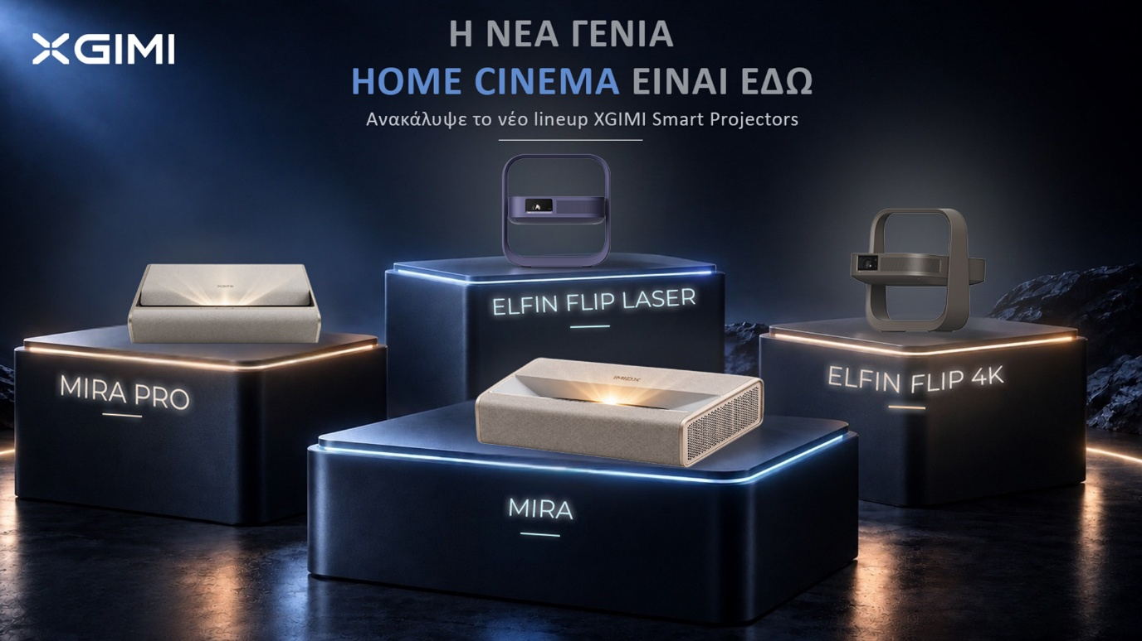

Athens – October 5th, 2026 – Wavemotion S.A., the official distributor of XGIMI in Greece, presents the innovative brand of smart projectors, which is expanding its offerings across price, image quality, and usage scenarios to better meet the needs of a wider range of users, with four new projectors: the portable laser projectors Elfin Flip 4K & Elfin Flip Laser, and the ultra-short-throw 4K models MIRA & MIRA Pro.

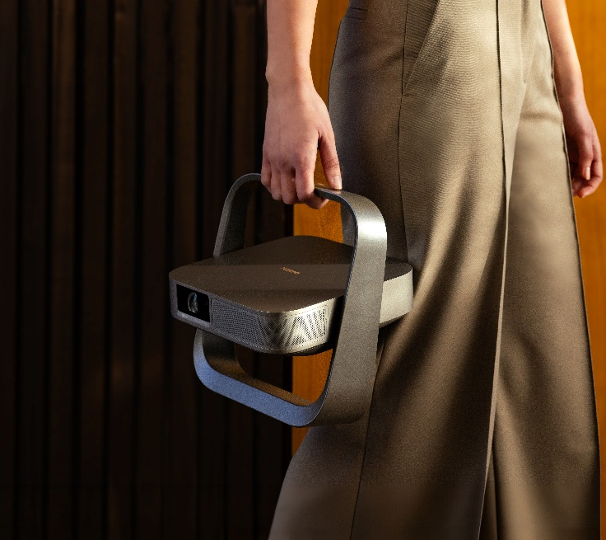
Elfin Flip 4k
The new flagship of the Elfin Flip series brings true 4K to a slim, book-sized body of just 1.55 kg. Its RGB Triple Laser engine delivers 1,600 ISO lumens, 20,000:1 dynamic contrast and 110% BT.2020 color, while optical zoom lets you size the picture without moving the projector. Gaming mode gets you 1ms input lag, VRR and ALLM for the first time in the Elfin family, and a 7W Harman Kardon speaker with Google TV completes a true room-to-room home cinema.

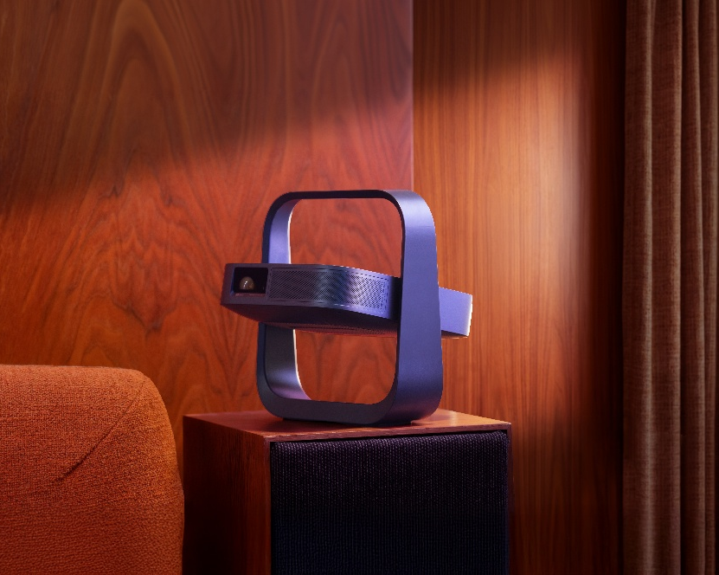
Elfin Flip Laser
The Elfin Flip Laser brings RGB Triple Laser technology to the most accessible model of the series. Full HD resolution, 1,600 ISO lumens and 110% BT.2020 coverage deliver vivid images from 40 to 200 inches. At just 1.38 kg, it moves easily from room to room, and its integrated handle and 150° adjustable stand let you project onto a wall or even the ceiling. Auto keystone, auto focus, a 7W Harman Kardon speaker and Google TV make it ready to play in seconds.

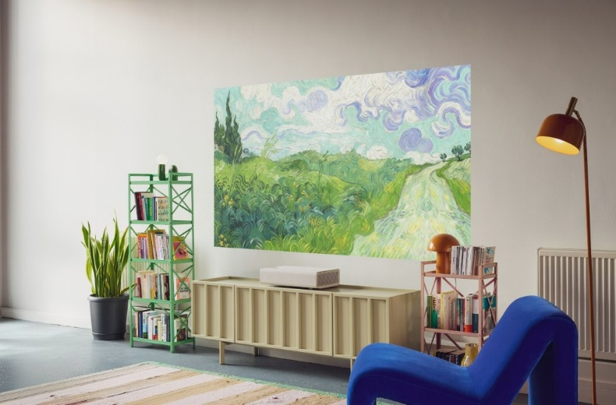
MIRA
MIRA is XGIMI’s new 4K ultra-short-throw laser projector, created for homes where design matters as much as the picture. Placed just 19 cm from the wall, it projects a 100-inch image, with no ceiling mount or cables across the room. RGB Triple Laser technology delivers 2,000 ISO lumens and 110% BT.2020 color with Dolby Vision, while its Moonlight Sand fabric finish blends into the living room. A 36W Harman Kardon system and Google TV complete the experience.

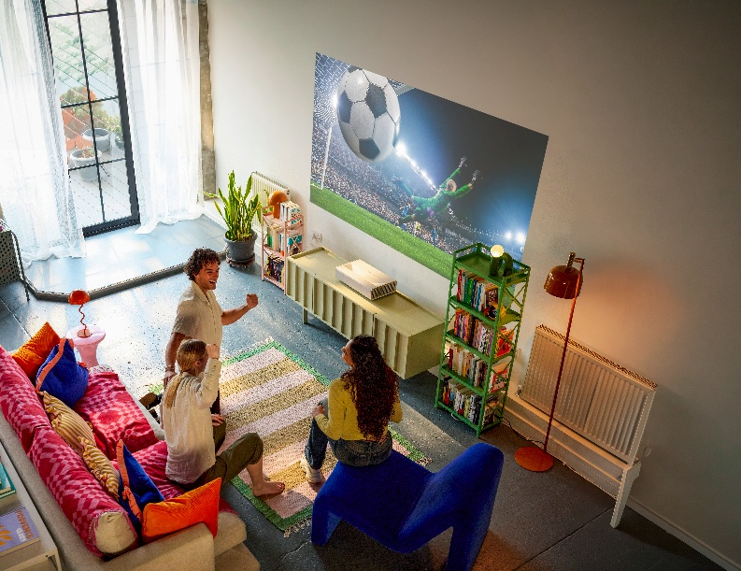
MIRA Pro
MIRA Pro brings the same elegant design to brighter, larger spaces. With 3,000 ISO lumens, the image stays vivid from sunny mornings to late nights, while 4K resolution, Dolby Vision and HDR10+ deliver true cinematic detail up to 120 inches. Gaming mode offers 1ms input lag with VRR and ALLM, while ISA 5.0 keeps the picture automatically aligned. New XGIMI WALL art designs, exclusively for MIRA, transform your atmosphere in an instant.

For more information, please visit XGIMI - Wavemotion.
Follow XGIMI on Instagram : XGIMI Technology Greece & Cyprus (@xgimitech_gr_cy)

About WaveMotion
WaveMotion, an importer and distributor, is seated in Athens Greece, operating on a wholesale basis, in the consumer electronics, telecommunications and computer industry for over 35 years. WaveMotion S.A. retains the official, exclusive, distribution for the Greek market of important Houses- in leading positions in the Global Arena, like JBL, Harman Kardon, XGIMI, Dreame, KEF, Duux, Native Union. Brand Development is the core skill of WaveMotion Team. The vision of our people is to expand WaveMotion’s Brands selection, following our tagline’s principles –Technology, Aesthetics, Design- and continue this journey of Ours, introducing compellingly and establishing decisively these Brands, in the eyes of our Customers.

About XGIMI Technology
Since 2013, the state-of-the-art XGIMI projectors have helped countless people worldwide to create genuinely immersive audio-visual experiences. Working with reputable partners like Google, Harman Kardon, Dolby Vision, and Texas Instruments, XGIMI builds all-in-one entertainment devices, perfected due to their user-oriented philosophy. Through industry-leading innovation, streamlined setups, and unique designs, XGIMI always strives to develop the best home and portable projectors for everyone to enjoy.

