Press release
JBL Greece ( Official Distributor WaveMotion S.A) For direct publication.
Tel.:210-9244505 Date:08/10/2026
Email: jbl_greece@wavemotion.gr

JBL's new PartyBox Ultimate 2 & Pulse 6 have just arrived!
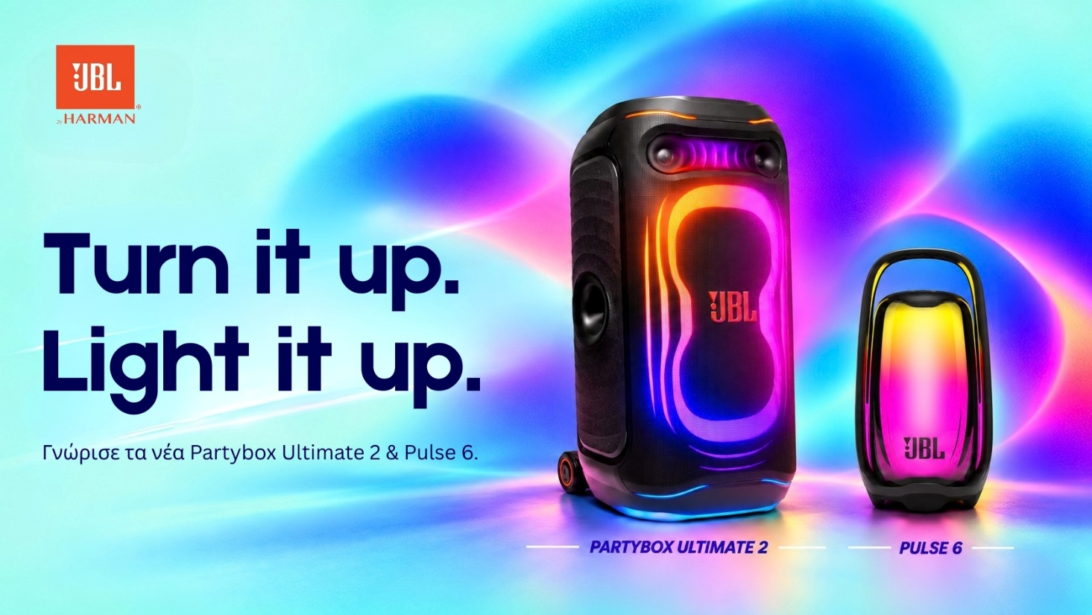
More power, smarter sound and lighting that steals the show!

Two new launches for everyone who wants the party to be heard and seen! The new long awaited JBL PartyBox Ultimate 2 has arrived, and it is the most powerful party speaker JBL has ever created, with 1,500W of Legendary Sound and an integrated touchscreen to control everything. The new redesigned JBL Pulse 6 brings bigger sound and an even brighter 360° lightshow to a portable Bluetooth speaker, with an illuminated handle and up to 12 hours of battery life. Both feature AI Sound Boost technology and connect with other compatible speakers via Auracast™, because a great party never stops at one speaker.
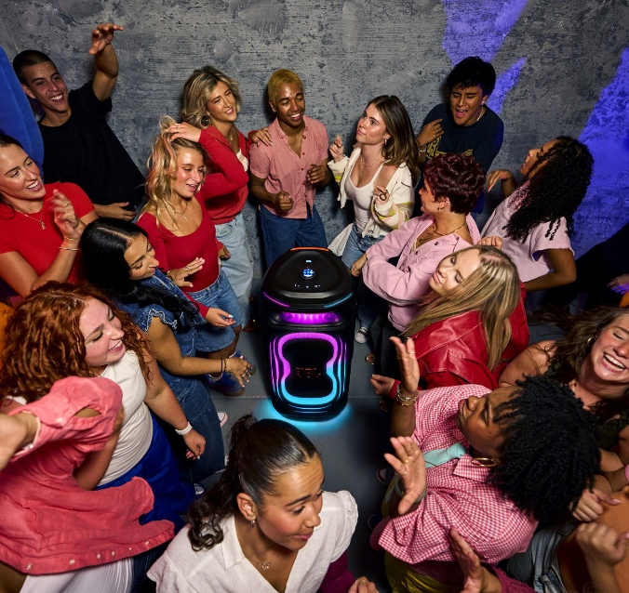
Partybox Ultimate 2
When the party gets bigger, PartyBox Ultimate 2 is ready. With 1,500W of JBL Legendary Sound that fills up to four basketball courts, over 36% more power than the previous generation. A completely upgraded acoustic architecture combines dual pro-grade PEN tweeters with horns, the same found in JBL's Professional systems, with dual 5-inch mid-range drivers and dual 10-inch woofers, for deeper bass, richer vocals and more detail. AI Sound Boost analyses the audio in real time, keeping the sound dynamic with very low distortion, even at maximum volume.

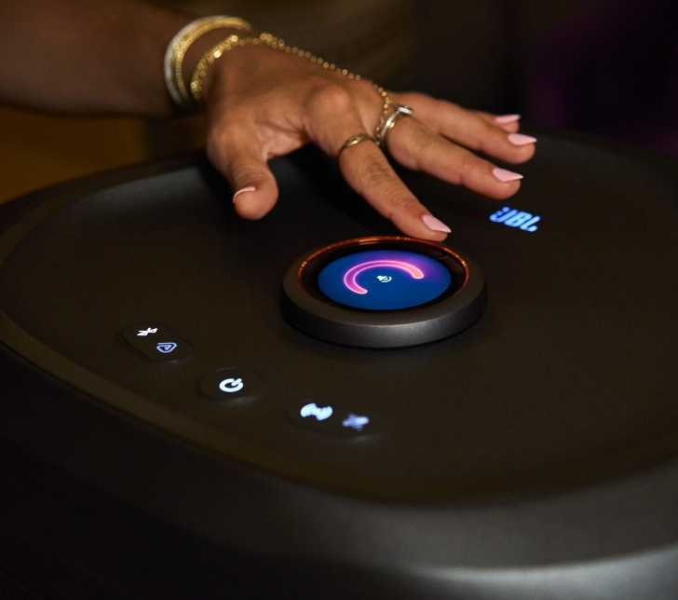
The new lightshow combines dynamic ripple effects, multi-layer lighting and bold floor projection. It comes with an integrated touchscreen that lets you control everything: the volume dial doubles as a touch controller for instant access to music, lighting and key settings, and shows which song is playing and which lightshow is on. Feel like karaoke? Connect any microphone, and EasySing AI Vocal Removal turns your favorite songs into karaoke-ready tracks by removing the vocals! Larger, sturdier wheels and an ergonomic handle make it easy to take along.

Key features:
- 1,500W JBL Legendary Sound with dual PEN tweeters with horns, dual 5" mid-range drivers, dual 10" woofers and dual bass ports
- AI Sound Boost for clarity and low distortion at every volume
- Revamped lightshow with multi-layer lighting and floor projection
- Touchscreen top panel with built-in EasySing AI Vocal Removal and party games
- Optical input for TV karaoke, XLR line-in for DJ equipment and lossless USB-C playback
- Wi-Fi 6, Bluetooth LE Audio, Auracast™, AirPlay 2, Google Cast™, Roon Ready, Spotify Connect, Tidal Connect and Qobuz Connect
- Full control of lighting, features and settings with the JBL One App
- Larger wheels and an ergonomic, sturdy handle
- IPX4 splashproof design
- Works with JBL EasySing Mics
- Made with recycled materials

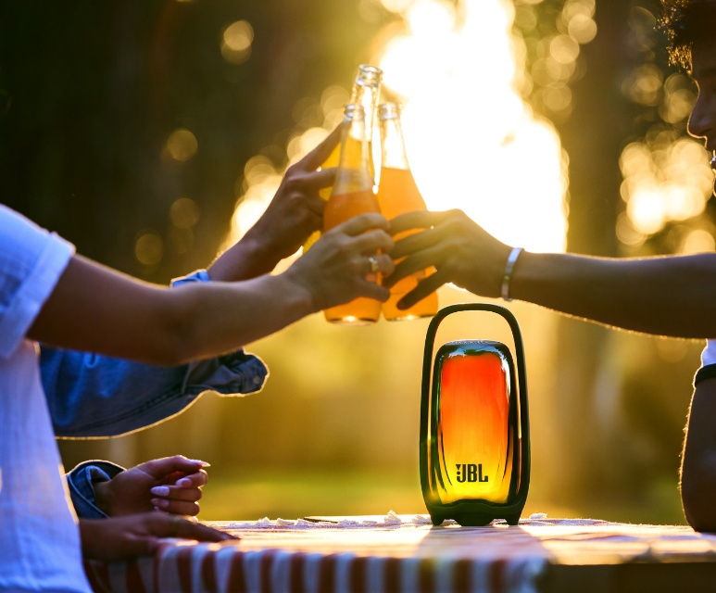
Pulse 6
The new Pulse 6 replaces the previous model, with upgraded sound and renewed design. JBL Legendary Sound, enhanced by AI Sound Boost, and an upgraded acoustic design deliver more natural, balanced sound with deeper bass, in an immersive 360° experience. The 360° lightshow comes with new choreographed effects and ambient modes, while the new illuminated metal handle has a lightshow of its own and makes the speaker easier to carry.

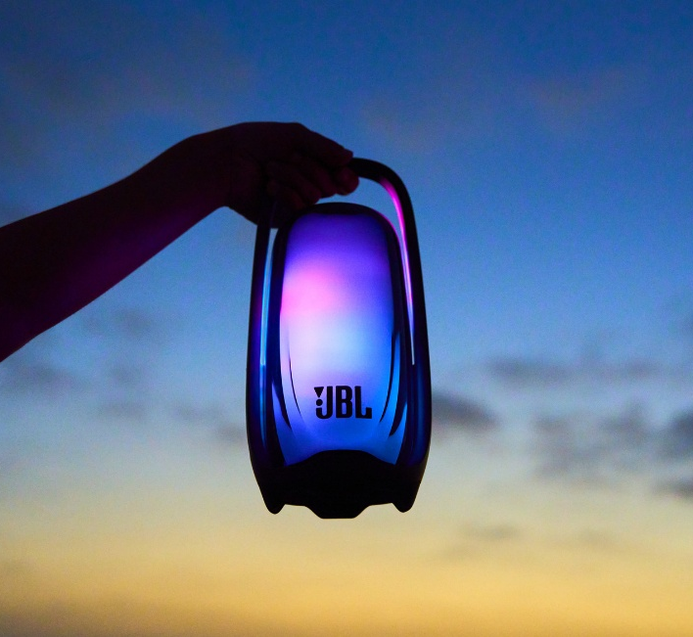
Ready to switch off after a long day? Sunset Mode gradually dims the lighting over a countdown you set in the JBL One app. A quick double tap turns on the new Bedside Lamp feature for warm, comforting light. And when one Pulse isn't enough, Auracast™ connects it with other compatible JBL speakers, while sound and lighting sync with other Pulse 6 speakers, compatible PartyBox speakers and JBL PartyLights. With up to 12 hours of battery life and IP68 water and dust protection, it's ready to go wherever you do.

Key features:
- JBL Legendary Sound with AI Sound Boost
- 360° choreographed lightshow with integrated illuminated handle
- 16 light themes: 10 ambient (Universe, Firefly, Sea, Campfire, Aurora, Blossom, Cheers, Storm, Sky, Hover) and 6 party (Neon, Loop, Bounce, Trim, Switch, Freeze)
- Auracast™ multi-speaker connectivity and stereo pairing
- Synchronized sound and lighting with compatible JBL PartyBox speakers and the JBL PartyLight Stick
- Bluetooth® 6.0, lossless USB-C playback and easy karaoke setup with the JBL EasySing Mic Mini
- Bedside Lamp feature with a quick double tap
- Full experience in the JBL One App: light themes, Sunset Mode, mood-setting sounds, EQ settings and more
- Up to 12 hours of battery life
- IP68 waterproof and dustproof
- Made with recycled materials, including 93% recycled metal in the handle

For more information, please visit το site.
Follow JBL Greece & Cyprus on socials Facebook , Instagram, Tiktok

About WaveMotion
WaveMotion, an importer and distributor, is seated in Athens Greece, operating on a wholesale basis, in the consumer electronics, telecommunications and computer industry for over 35 years. WaveMotion S.A. retains the official, exclusive, distribution for the Greek market of important Houses- in leading positions in the Global Arena, like JBL, Harman Kardon, XGIMI, Dreame, KEF, Duux, Native Union. Brand Development is the core skill of WaveMotion Team. The vision of our people is to expand WaveMotion’s Brands selection, following our tagline’s principles –Technology, Aesthetics, Design- and continue this journey of Ours, introducing compellingly and establishing decisively these Brands, in the eyes of our Customers.

About HARMAN
HARMAN (harman.com) designs and manufactures products and solutions for automotive, consumers and businesses worldwide, including connected car systems, audio and video products, enterprise automation solutions and services that support the Internet of Things. With leading brands such as AKG®, Harman Kardon®, Infinity®, JBL®, Lexicon®, Mark Levinson®, and Revel®, HARMAN is admired by audio enthusiasts, musicians, and entertainment venues around the world. More than 50 million cars on the road today are equipped with HARMAN audio systems. Our software services support and are compatible with billions of mobile devices and systems that are connected, integrated, and secure across all platforms, from home to car to mobile. HARMAN employs approximately 30,000 people throughout the Americas, Europe, and Asia. In March 2017, HARMAN became a subsidiary of Samsung Electronics Co., Ltd.

