**For more information: Press Release**

**WaveMotion S.A** For direct publication

Τηλ.:210-9244505 Hμ.: 10/9/2025

Email: [Partners@WaveMotion.gr](mailto:Partners@WaveMotion.gr)

**XGIMI introduces the new MoGo 4:**

**Just Play your Way**

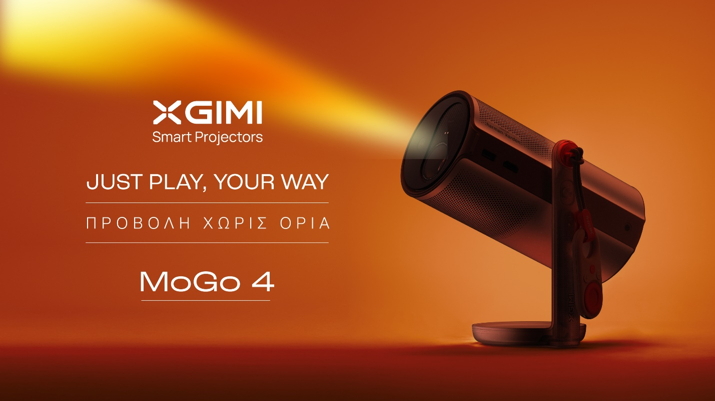

Athens – September 10th, 2025 – Wavemotion S.A., the official distributor of XGIMI in Greece, presents the innovative brand of smart projectors, which promises to transform the home entertainment and outdoor portable cinema experience with the launch of the new MoGo 4 portable projector. Designed to offer cutting-edge technology and bold, modern design, it redefines the world of portable entertainment.

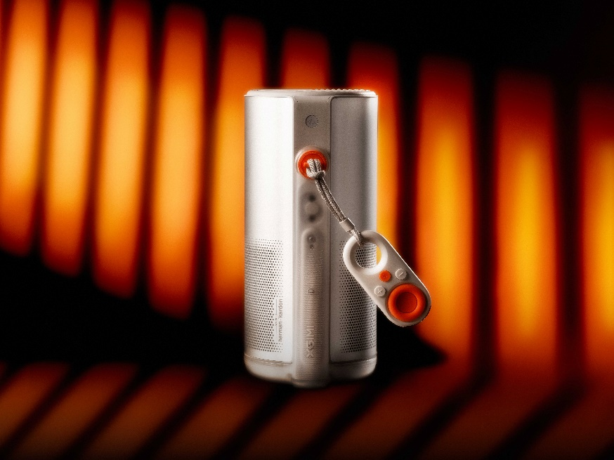**iF DESIGN Award**

The XGIMI MoGo 4 projector is an innovative portable smart projector designed to meet the diverse needs of modern lifestyles. Its compact size and built-in battery offer portability in a variety of situations, from movie nights at home to outdoor adventures and social gatherings. The innovative magnetic lens kit transforms spaces with soft lighting, creating a cozy atmosphere. The translucent design of the base, combined with the latest XGIMI technology and Harman/Kardon sound, offers a rich experience, setting new standards in its category.

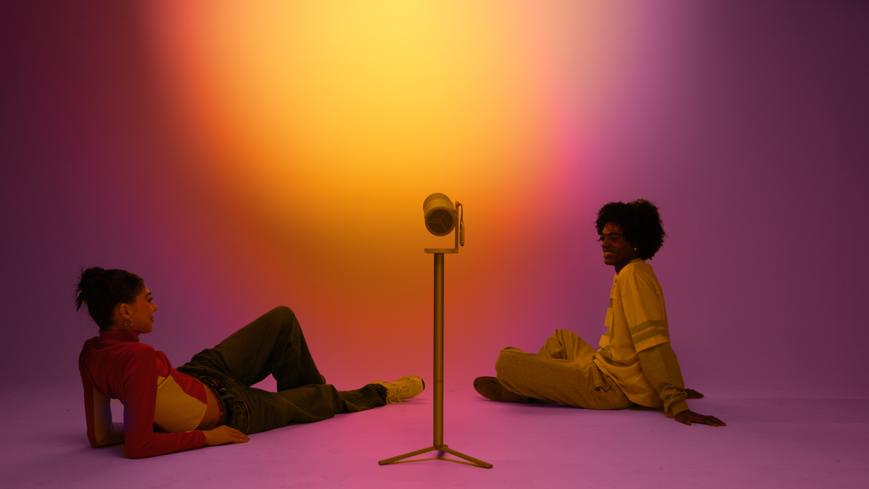**All-in-One Atmosphere**

The MoGo 4 is a portable 0.23-inch DLP smart projector with an LED light engine. With 1080p resolution, it has a compact design, about the size of a large thermos. XGIMI claims 450 ISO lumens, making this projector ideal for nighttime use or in completely dark rooms. Set the perfect mood with different Magnetic Optical Filters and Ambient Lighting Mode. Use it as a premium speaker or let the lights move to the beat for a dynamic, immersive atmosphere.

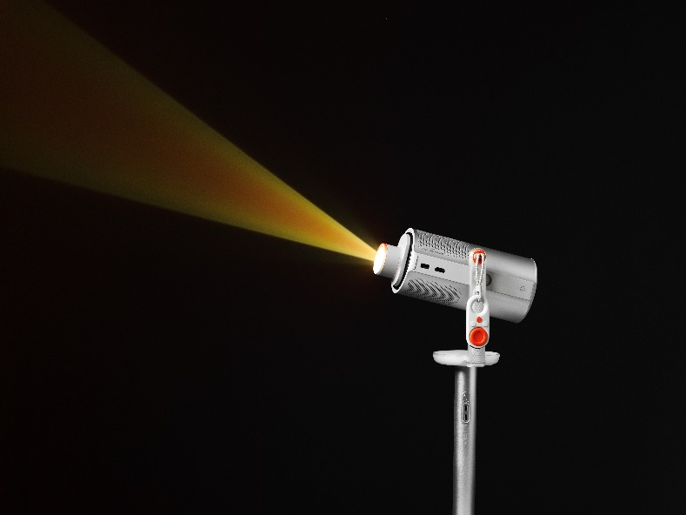

**Harman/Kardon sound**

Listen to your music at high volume with dual 6W Harman Kardon speakers with powerful bass and Dolby Audio support. With multiple audio modes, such as movies, music, games, and sports, the options are endless. Ambient Speaker mode turns the projector into a Bluetooth speaker with atmospheric lighting when it's turned off. Fill your party with powerful, clear sound and combine Ambient Lighting mode to create a new mood in any environment.

**Unlimited fun and entertainment**

The built-in battery lasts up to 2.5 hours when playing videos in ECO mode and 6 hours for music. Using the PowerBase Stand doubles this number. Now with the option of using a power bank, you can enjoy more entertainment time, wherever you are.

**Availability and prices.**

The MoGo 4 will be available for purchase at €639.00 at WaveMotion Gallery and other authorized retail channels. The projector will also be available as a bundle with the exclusive PowerBase Stand at an attractive price of €719.00. All accessories will also be available for purchase separately.

Για περισσότερες πληροφορίες, επισκεφτείτε [XGIMI - Wavemotion](https://www.wavemotion.gr/el/our_brands/xgimi/).

Βρείτε μας στο Instagram : [XGIMI Technology Greece & Cyprus (@xgimitech_gr_cy)](https://www.instagram.com/xgimitech_gr_cy/)

**About WaveMotion**

WaveMotion, an importer and distributor, is seated in Athens Greece, operating on a wholesale basis, in the consumer electronics, telecommunications and computer industry for over 35 years. WaveMotion S.A. retains the official, exclusive, distribution for the Greek market of important Houses- in leading positions in the Global Arena, like JBL, harman/kardon, Cambridge Audio, Q Acoustics, QED, Goldring, rapoo, Native Union, Livall. Brand Development is the core skill of WaveMotion Team. The vision of our people is to expand WaveMotion’s Brands selection, following our tagline’s principles –Technology, Aesthetics, Design- and continue this journey of Ours, introducing compellingly and establishing decisively these Brands, in the eyes of our Customers.

**About XGIMI Technology**

Since 2013, the state-of-the-art XGIMI projectors have helped countless people worldwide to create genuinely immersive audio-visual experiences. Working with reputable partners like Google, Harman Kardon, Dolby Vision, and Texas Instruments, XGIMI builds all-in-one entertainment devices, perfected due to their user-oriented philosophy. Through industry-leading innovation, streamlined setups, and unique designs, XGIMI always strives to develop the best home and portable projectors for everyone to enjoy.