For more information: Press Release
WaveMotion S.A For direct publication
Τηλ.:210-9244505 Hμ.: 06/9/2023
Email: Partners@WaveMotion.gr

JBL and XGIMI offer a VIP experience of watching the football grand final and lots of prizes!
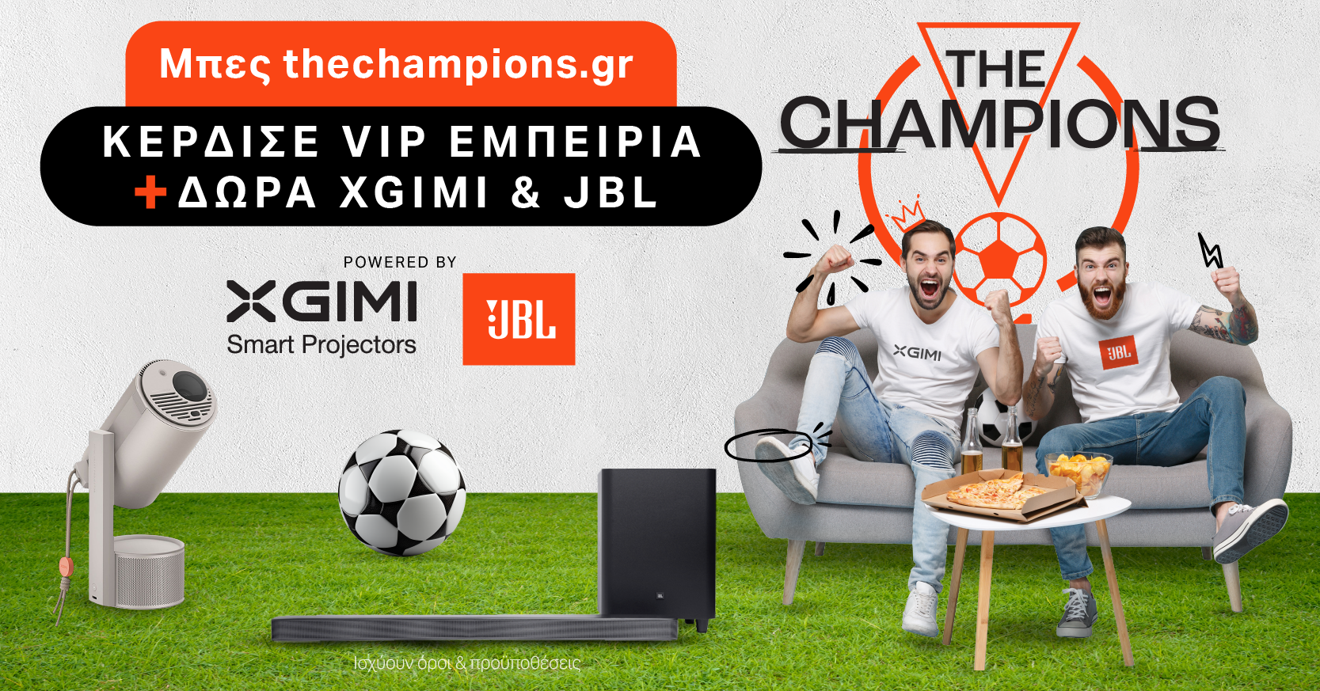

Athens – May 16th 2025 – JBL and XGIMI (Official Distributors WaveMotion S.A.) announce their collaboration for the organization of a special contest, offering fans the opportunity to experience the football Grand Final on May 31st in a high quality viewing experience, designed exclusively for the occasion, and many more prizes.

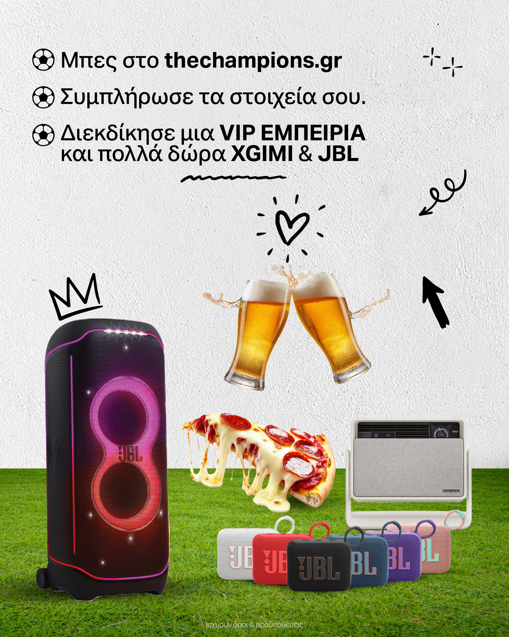

The Champions competition, hosted on thechampions.gr, will award one winner of the VIP experience, who will have the opportunity to enjoy the match together with 5 people of their choice, in a specially designed exclusive space with a state-of-the-art entertainment system, designed with audio products by JBL and video products by XGIMI.

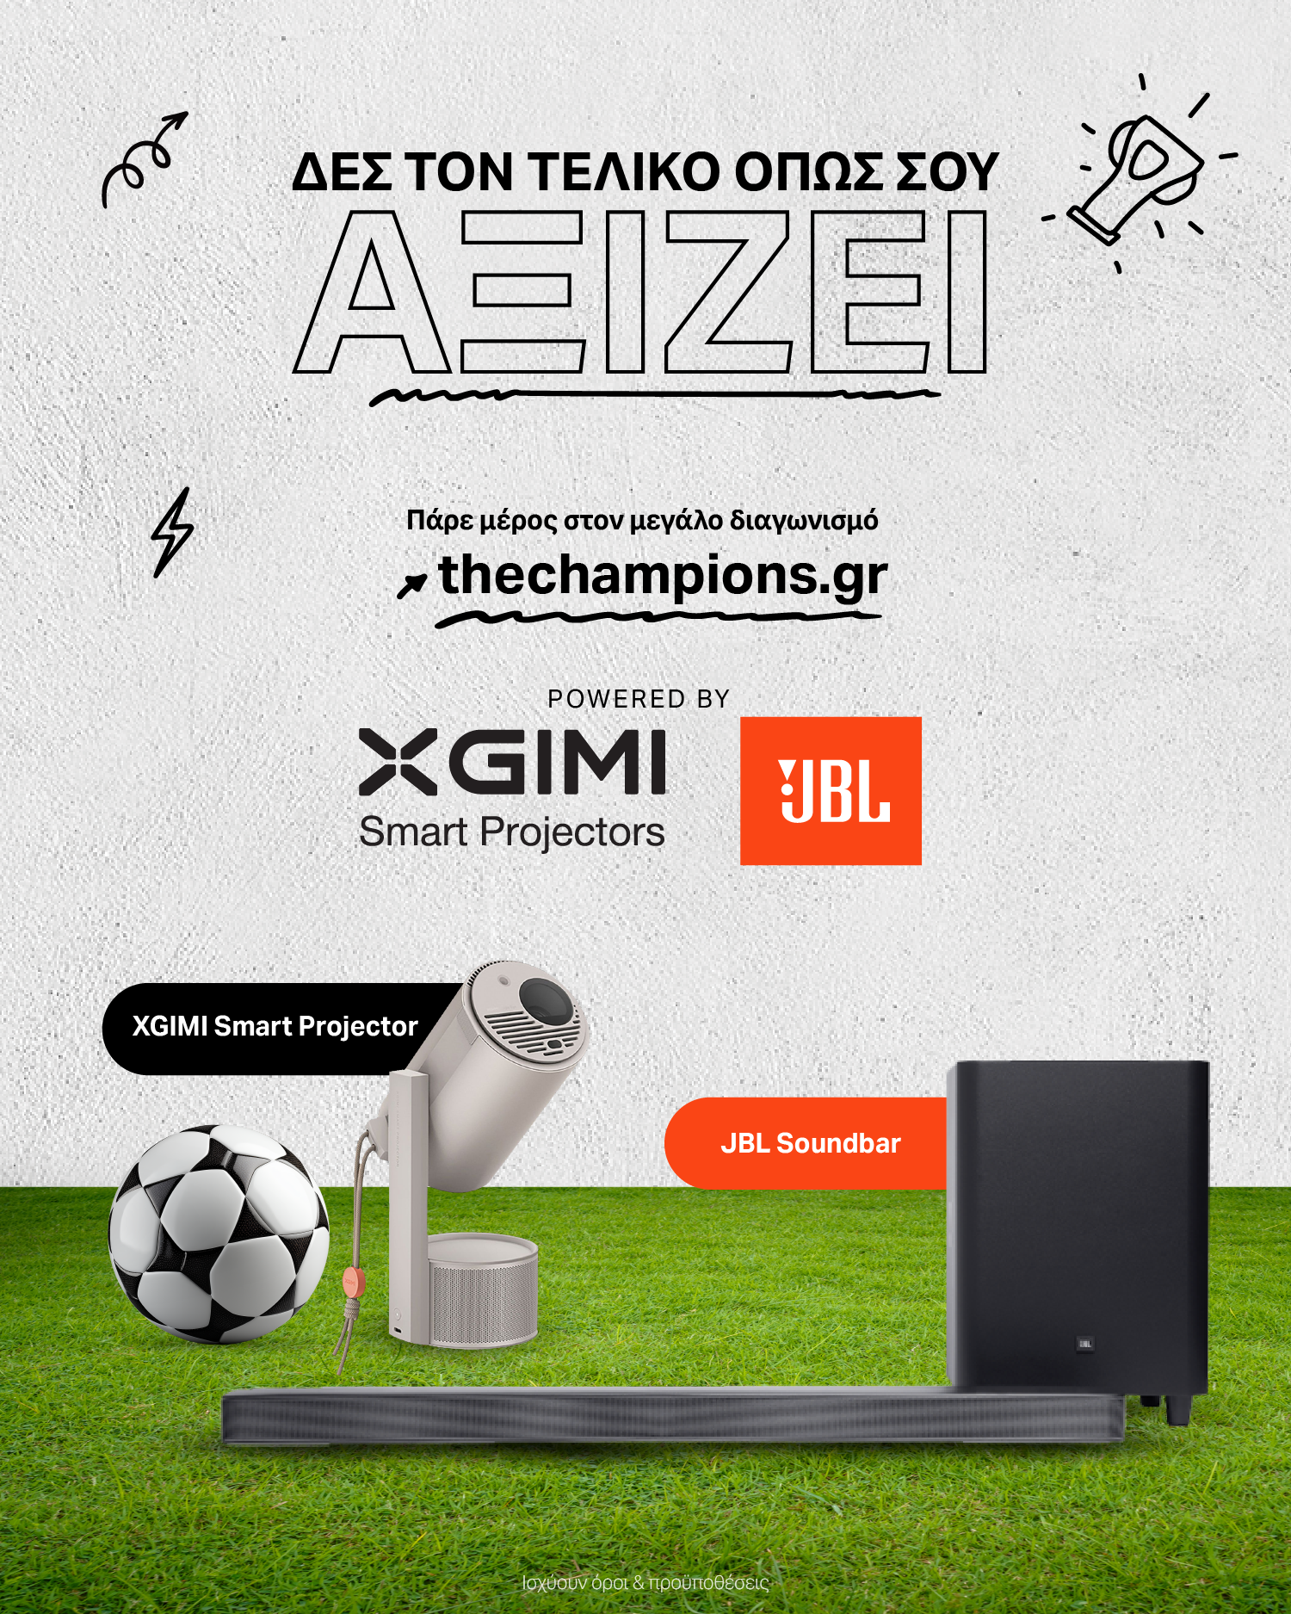
The big gifts of the contest

The grand prize winner's experience includes a 200-inch projection via XGIMI Smart Projector, amplified sound from a JBL Soundbar, and full hospitality coverage - food, drinks and amenities, all at the organizers' expense, as if they were in the stadium suite.

The other Gifts include:
- 1 portable Smart Projector XGIMI MoGo 3 Pro, which will be drawn among the VIP experience attendees on the night of the final.
- 10 JBL GO 4 portable speakers, which will be given by draw to 10 participants of the competition.

Participation in the process is simple and open until 26 May. Those interested are invited to visit thechampions.gr, fill in the relevant form and enter the contest.

Discover XGIMI on our site XGIMI (xgimi.gr)
and our social Facebook , Instagram

Find JBL on our site Home | JBL (jblgreece.gr)
and our social Facebook , Instagram , Tiktok

About WaveMotion
WaveMotion, an importer and distributor, is seated in Athens Greece, operating on a wholesale basis, in the consumer electronics, telecommunications and computer industry for over 35 years. WaveMotion S.A. retains the official, exclusive, distribution for the Greek market of important Houses- in leading positions in the Global Arena, like JBL, harman/kardon, Cambridge Audio, Q Acoustics, QED, Goldring, rapoo, Native Union, Livall. Brand Development is the core skill of WaveMotion Team. The vision of our people is to expand WaveMotion’s Brands selection, following our tagline’s principles –Technology, Aesthetics, Design- and continue this journey of Ours, introducing compellingly and establishing decisively these Brands, in the eyes of our Customers.

About HARMAN
HARMAN (harman.com) designs and engineers connected products and solutions for automakers, consumers, and enterprises worldwide, including connected car systems, audio and visual products, enterprise automation solutions; and services supporting the Internet of Things. With leading brands including AKG®, Harman Kardon®, Infinity®, JBL®, Lexicon®, Mark Levinson® and Revel®, HARMAN is admired by audiophiles, musicians and the entertainment venues where they perform around the world. More than 50 million automobiles on the road today are equipped with HARMAN audio and connected car systems. Our software services power billions of mobile devices and systems that are connected, integrated and secure across all platforms, from work and home to car and mobile. HARMAN has a workforce of approximately 30,000 people across the Americas, Europe, and Asia. In March 2017, HARMAN became a wholly-owned subsidiary of Samsung Electronics Co., Ltd..

About XGIMI Technology

Since 2013, the state-of-the-art XGIMI projectors have helped countless people worldwide to
create genuinely immersive audio-visual experiences. Working with reputable partners like
Google, Harman Kardon, Dolby Vision, and Texas Instruments, XGIMI builds all-in-one entertainment devices,perfected due to their user-oriented philosophy. Through industry-leading innovation,
streamlined setups, and unique designs, XGIMI always strives to develop the best home and
portable projectors for everyone to enjoy.

About VEESION (www.veesion.gr)
The independent advertising company VEESION was created in 2020 during the lockdown. Open to challenges and collaborations, it is a creative partner to companies in Greece and the United Arab Emirates, offering integrated communication services: Advertising, Branding, Digital & social media, Brand Experience, Video Content, Guerrilla & Growth Hacking Marketing. VEESION constantly invests in talented people with exceptional character, in new technologies and in training. VEESION’s DNA consists of 4 main elements: Innovation, creativity, empathy and efficiency.

The Champions campaign was designed and implemented by Veesion, as part of an integrated campaign that includes organic social media and paid digital content, contest microsite, influencer partnerships, newsletter, press release, as well as the full organization and execution of the event.

