**For more information: Press Release**

**JBL Greece ( Official Distributor WaveMotion S.A)** For direct publication.

Tel.:210-9244505 Date:15/04/25

Email: [jbl_greece@wavemotion.gr](mailto:jbl_greece@wavemotion.gr)

**Take your JBL with you at the village**

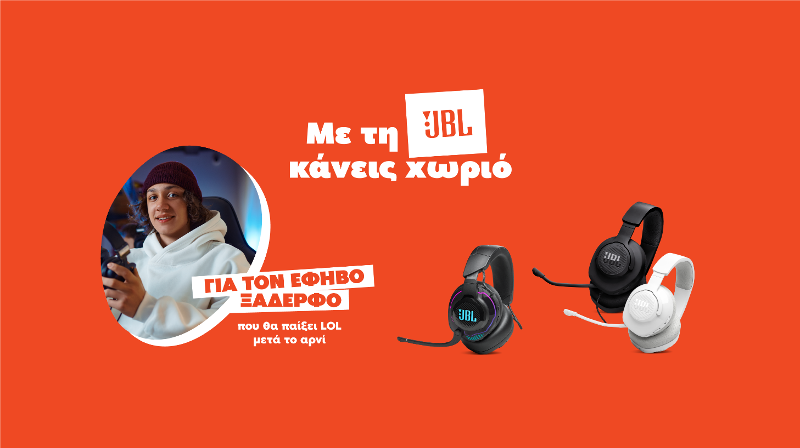**this Easter!**

Athens – April 15th 2025. JBL Greece (Official Distributors WaveMotion S.A.) presents JBL's new Easter campaign. This year, we share Easter with our loved ones and accompany our memories and experiences with JBL sound. Whether you're looking for gifts, the sound that will make the Easter table unforgettable, or even headphones so you can't hear anyone, JBL has everything you need, because with JBL you always make a village.

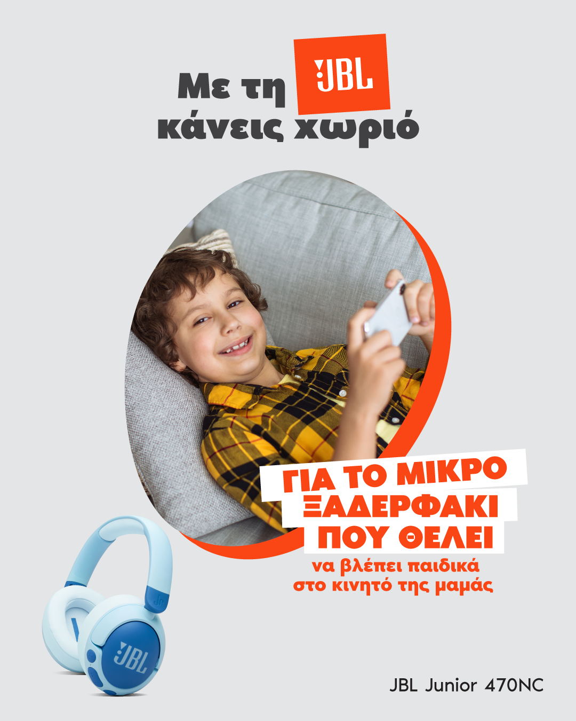

The campaign is signed with the message “With JBL you can make a village”, which has a double meaning here, taking us directly to Easter holidays and memories on the one hand, and on the other hand stating that with JBL you can always find what you need - according to the meaning of the slogan itself. The campaign features classic characters from the Easter table for whom JBL finds the perfect match.

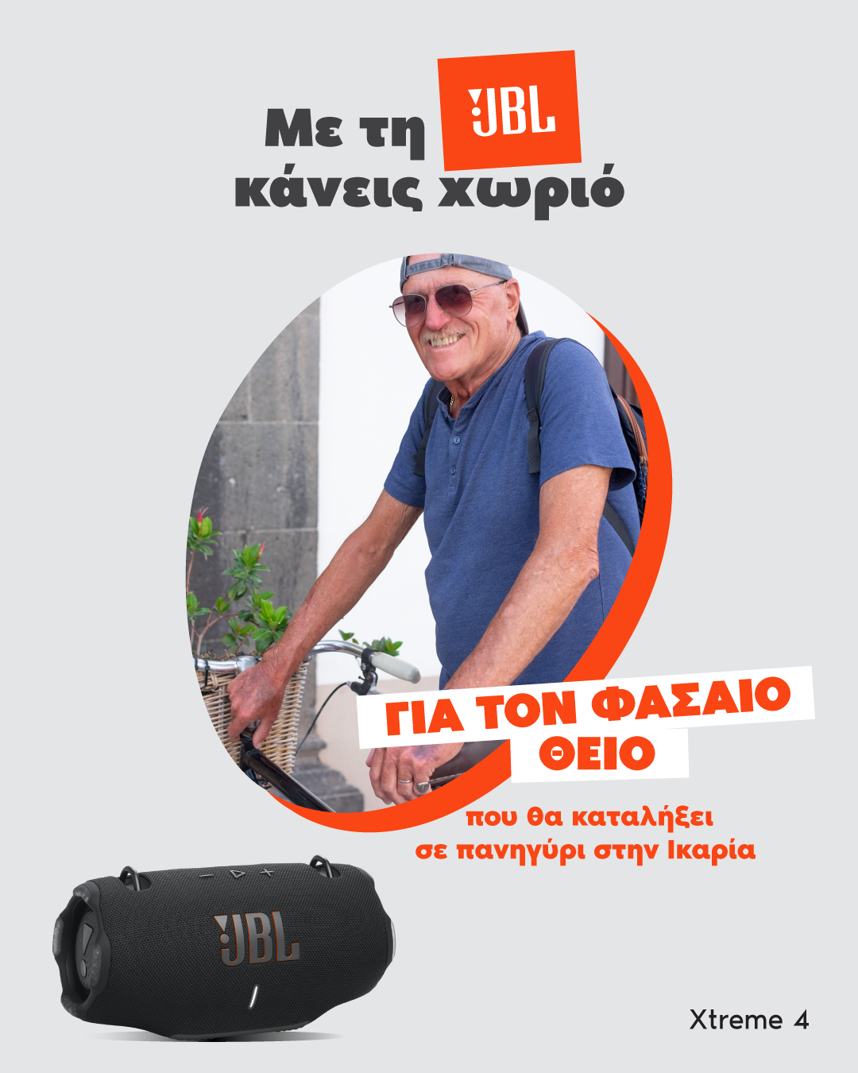 For the noisy uncle who always ends up at a fair in Ikaria, JBL proposes the XTREME 4 - with up to 24 hours of autonomy and 6 additional hours with Playtime Boost mode, for non-stop partying wherever you are. For the cousin turned vegan, the ideal choice is the Clip 5, designed with partial use of recycled materials - perfect for the eco-conscious. The cousin who comes to the village for detox and yoga will find an ally in the Soundgear Sense, with JBL OpenSound technology for ultimate freedom and wellness.

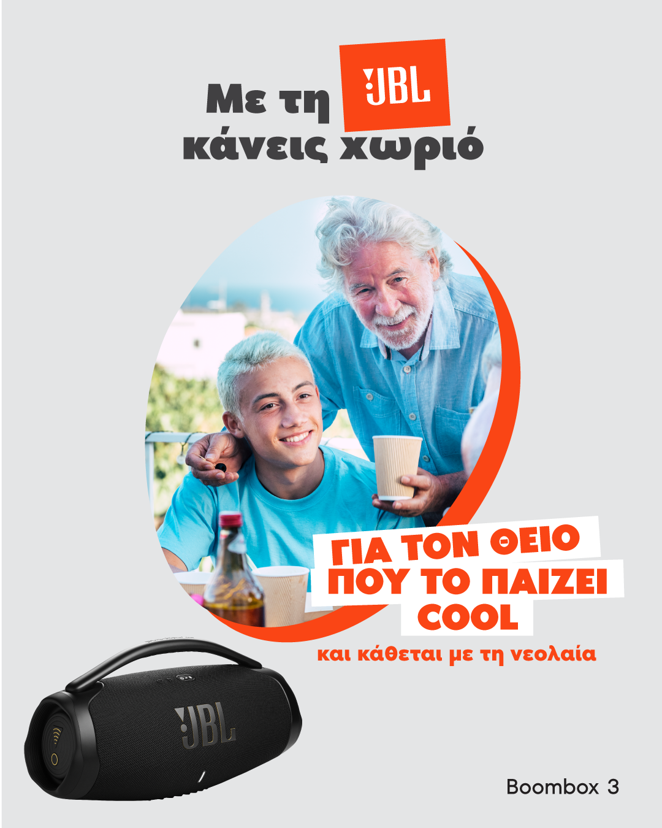

The teenage cousin who plays LOL after lamb can't help but have the Quantum 910, which allows him to play and charge at the same time.

The uncle who plays it cool and always sits with the youth will stand out with the Boombox 3, thanks to its loud sound and powerful bass.

The guy who climbs to the rooftop to get a signal will appreciate the Tour Pro 3, with immersive sound, six microphones and JBL Crystal AI Algorithm technology for flawless calls.

JBL is offering experiences for every family member at the Easter table this year. Enjoy beautiful festive moments wherever you are with the unique sound of JBL.

More information on our site [Home | JBL (jblgreece.gr)](https://www.jblgreece.gr/)

And our socials [Facebook](https://www.facebook.com/JBLGreece) ,  [Instagram](https://www.instagram.com/jbl_greece/), [Tiktok](https://www.tiktok.com/@jbl_greece?lang=en)

**About WaveMotion**

WaveMotion, an importer and distributor, is seated in Athens Greece, operating on a wholesale basis, in the consumer electronics, telecommunications and computer industry for over 35 years. WaveMotion S.A. retains the official, exclusive, distribution for the Greek market of important Houses- in leading positions in the Global Arena, like JBL, harman/kardon, Cambridge Audio, Q Acoustics, QED, Goldring, rapoo, Native Union, Livall. Brand Development is the core skill of WaveMotion Team. The vision of our people is to expand WaveMotion’s Brands selection, following our tagline’s principles –Technology, Aesthetics, Design- and continue this journey of Ours, introducing compellingly and establishing decisively these Brands, in the eyes of our Customers.

**About HARMAN**

HARMAN (harman.com) designs and engineers connected products and solutions for automakers, consumers, and enterprises worldwide, including connected car systems, audio and visual products, enterprise automation solutions; and services supporting the Internet of Things. With leading brands including AKG®, Harman Kardon®, Infinity®, JBL®, Lexicon®, Mark Levinson® and Revel®, HARMAN is admired by audiophiles, musicians and the entertainment venues where they perform around the world. More than 50 million automobiles on the road today are equipped with HARMAN audio and connected car systems. Our software services power billions of mobile devices and systems that are connected, integrated and secure across all platforms, from work and home to car and mobile. HARMAN has a workforce of approximately 30,000 people across the Americas, Europe, and Asia. In March 2017, HARMAN became a wholly-owned subsidiary of Samsung Electronics Co., Ltd..