For more information: Press Release
WaveMotion S.A For direct publication
Τηλ.:210-9244505 Date: 20/12/2023
Email: Partners@WaveMotion.gr
XGIMI: World’s leading smart projector brand
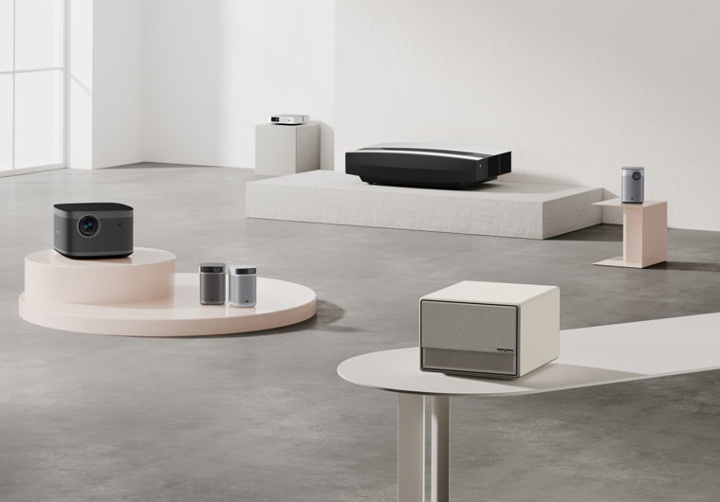
at WAVEMOTION’S portfolio!
Athens, December 2023. – WaveMotion SA announces the official distribution for Greece of XGIMI, bringing the most advanced projection technology in Greek Market.
Bringing a genuine cinematic experience to the home, while also allowing you to take the cinema with you anywhere you go, XGIMI paves the way for modern projector technology. In the last 8 years, XGIMI has earned 38 international design and innovation awards, including the world's 4 major industrial design awards, rightfully gaining recognition for its dedication to innovation and quality. With products ranging from high-performance smart projectors to laser TVs, XGIMI revolutionizes your audio-visual experience, delivering what are likely the best value large-screen projection products in the market.

Why XGIMI?
Through performance and intuitiveness, XGIMI provides a hassle-free set up for its devices, contributing much to their portability, while developing aesthetically pleasing designs that compliment every home. This attitude towards versatility, always with the user in mind, has provided the market with products such as the portable Halo+ and the world’s first 4K Long-Throw Home projector HORIZON Ultra. Furthermore, XGIMI aims to enhance the user’s experience through partnerships with companies such as Google and Harman/Kardon, providing comprehensible interfaces and impeccable sound quality. Through dedication and consistency, they strive to become a global market leader, and in their attempt at conquering the global market, they strive to also conquer your senses, turning your home into a cinema, and your excursion into an adventure.
XGIMI’s collection includes Portable Projectors, Home Projectors and Laser Projectors.
Portable Projectors: A Cinema You Can Take With You
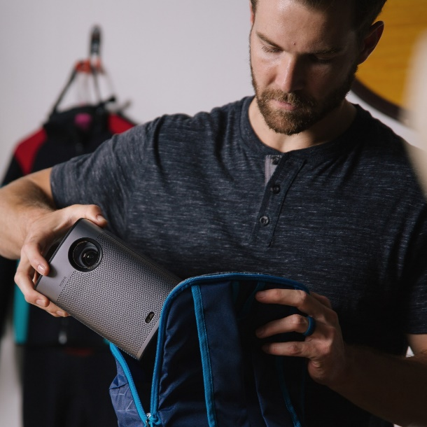
A portable HD projector is a compact device that allows you to project high-quality images and videos onto a large screen or any flat surface. It is a type of projector that is designed to be lightweight, easy to carry, and can fit in a small bag or backpack. HD Portable projectors are becoming increasingly popular, especially among people who are always on the go and need a versatile device that they can use for both work and leisure. Effortless set up and compact design, XGIMI’s portable projectors are designed for home entertainment, outside of your home. With reliable built-in batteries and adjustable screens, these versatile devices faithfully recreate the experience your 1080p TV can bring to your living room, by bringing that experience anywhere. Moreover, an HD portable projector is also an excellent option for business professionals who need to give presentations on the go. With its compact size and lightweight design, a portable HD projector can easily fit into a briefcase or backpack, making it easy to transport to meetings and conferences.

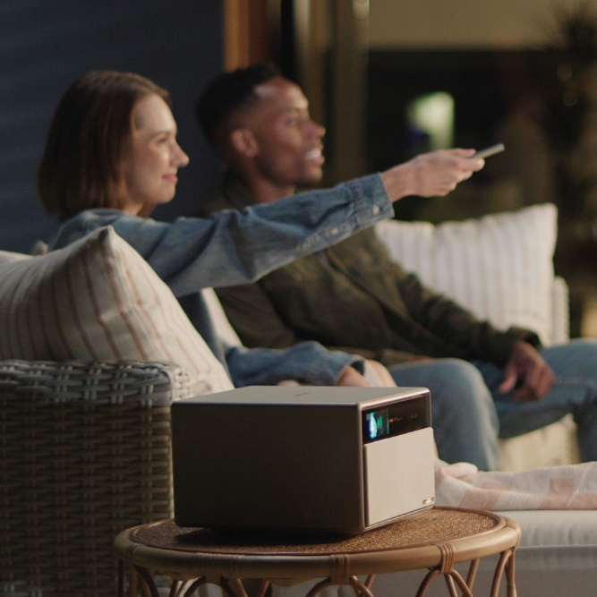
Home Projectors: Redefining Home Theater
Are you looking for an immersive movie-watching experience at home? A 4k home theater projector could be just what you need to transform your living room into a cinematic paradise. It can deliver an immersive viewing experience with stunning picture quality that can rival that of a commercial theater. Through performance and intuitiveness, XGIMI has reimagined and revolutionized what “Home Cinema” means, bringing a cinematic experience to the comfort of your own home, while not confining you to your living room. Due to Intelligent Screen Adaptation technology and their small size, unlike a hefty TV, these projectors can be moved around and used in any room, essentially turning any part of your home into a cinema.

Laser Projectors: Your Next TV Is Not a TV
Laser projects significantly improve the overall image quality of home theater projections. The laser technology provides brighter and more vivid colors, deeper blacks, and a better contrast ratio than traditional lamp-based projectors. Equipped with advanced Laser-powered Ultra Short-Throw technology, XGIMI manages to deliver a breathtaking 4K UHD resolution, displaying vivid colors and exceptional brightness. Achieve stellar visual detail, perfectly manifesting games, TV shows and movies on your wall, while taking up next to zero space. Laser projects significantly improve the overall image quality of home theater projections. The laser technology provides brighter and more vivid colors, deeper blacks, and a better contrast ratio than traditional lamp-based projectors.

You can find XGIMI’s Portable, Home Theater and Laser Projectors now in Authorized Resellers all over Greece. For more information, visit XGIMI | WaveMotion S.A. or find us on social media:
Instagram: https://www.instagram.com/xgimitech_gr_cy/

About WaveMotion
WaveMotion is an anonymous technology product importer based in Athens and active in the field of smart electronics, audio and video. “WaveMotion” refers to words such as: sound, light, image, power, speed, fun and suggests that as waves move constantly and with speed, so does technology in sound, image, telecommunications, IT. WaveMotion’s mission is to provide High Technology products that combine Cutting Edge Technology with Aesthetics and Modern Design. Today, WaveMotion officially distributes in the Greek market international brands that hold leading positions in their field such as harman/kardon, JBL, KEF, Q Acoustics, Audio Pro, QED, Goldring, rapoo, Livall and Native Union & XGIMI.
About XGIMI
Determined to revolutionize viewers’ audio-visual experience, XGIMI strives to deliver the best value large-screen projection products globally and create outstanding home theaters for every family to enjoy. XGIMI reimagines the Home and Outdoor Projector space by ensuring the best user experience through performance and intuitiveness. Developed to compliment every home decor, XGIMI projectors are hassle-free to set up and sport an aesthetically-pleasing design. This user-oriented attitude has helped XGIMI win 38 international awards, such as the EISA Best Buy Projector Award, CES Best Innovation Award, VGP Awards, iF Design Awards, Red Dot Design Award, and the Good Design Award.

