PRESS RELEASE
20 December 2023

TECH WONDERLAND: INNOVATION MEETS IMAGINATION IN THE MOST IMPRESSIVE GIFT GUIDE FROM NATIVE UNION

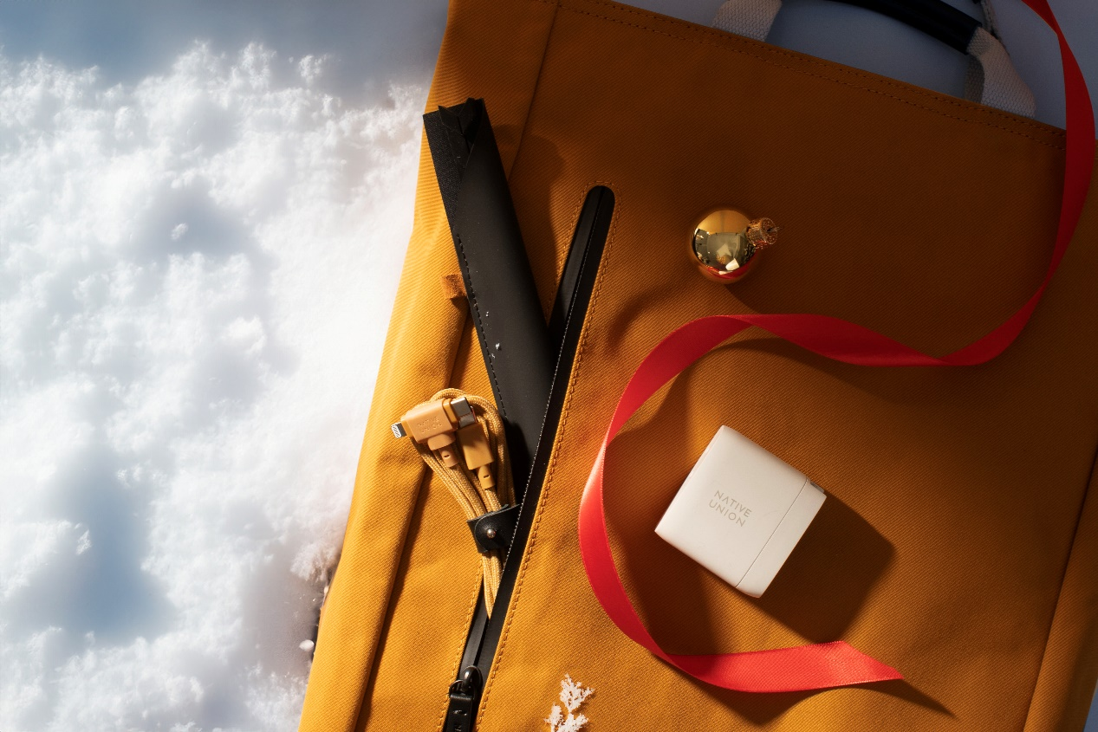

Whether you're choosing gifts for the minimalist in the group, the trendsetter or the tech enthusiast, Native Union has the perfect tech companion for everyone.

This holiday season, upgrade your gift list for your loved ones by investing in high-tech accessories from Native Union, the brand that epitomizes minimal design and innovation.

For your friends who are always on the...run, becoming "one" with the demanding and fast pace of the city, so they need an extra security for their device, Native Union's City Grip is the perfect gift suggestion. The smaller wrist version of the City Sling allows freedom of movement at every step. The device is always carried anywhere and everywhere without having to worry about anything.

Sleek in design to look like an accessory that can be worn on the hand while you talk on your phone or capture moments from a walk, the City Grip is compatible with most phone cases and is durable and can be adjusted to the wrist as you wish. Of course, it's a gift that's environmentally friendly, as it's made from 100% recycled polyester from plastic bottles. You'll find it in six unique colors, so you can choose the one that best suits your friends' taste.

For those who want to combine technology with fashion, Native Union has created the ultimate effortless mobile carrying accessory, the City Sling. Lightweight for comfortable use, sturdy enough to keep your device on you without any worry. This fashionable accessory offers convenience on the go and once attached to the phone case, it can be worn either in front of the neck or cross-body like a bag. Also made from 100% recycled polyester from plastic bottles, the City Sling can accompany its recipient from the morning at work to their workouts, as it is made to be worn everywhere.

Travel and adventure enthusiasts who never unplug from their work, however, will love the Native Union Backbag in Slate Green. It's not just a bag, but a great addition to their collection that combines practicality with sustainability, but also sophisticated and intelligent design. Modern and minimal, the Native Union Backbag is easy to pair with any look and has a 20 litre capacity so they can carry everything they need on any business or non-business trip.

Made from 100% recycled polyester (rPET) derived from plastic bottles, it cares for the environment, demonstrating Native Union's commitment to a greener and more sustainable future.

The Backpack's interior conceals a padded laptop sleeve that accommodates devices up to 16", while mesh pockets accommodate cables, chargers and other essential accessories.

At the same time, the key strap, a water bottle holder and a discreet hidden pocket add an extra layer of convenience to any commute and any trip.

As for its durability? The Native Union Backpack features a waterproof finish, reinforced stitching, YKK zippers and military-grade Cordura fabric in the areas where it's most exposed, so it can withstand anything and be carried even in rainy weather.

But what else does someone who travels and has a backpack on their back need? Thick organic cotton straps provide excellent comfort when using the backpack, while the sturdy top handle provides versatility in tote style.

Finally, thanks to the luggage strap that doubles as a luggage strap, it transforms into a stylish solution for storing straps during travel.

For the techie who always follows the latest technology trends but also wants to be stylish in terms of appearance, Native Union has protective cases for all versions of the iPhone 15. This gift is special not only because of its elegance which will enhance the personal style of any loved one, but because it is environmentally friendly.

The Native Union Case iPhone 15 (+ Pro, Pro Max) is made from 100% recycled materials, with Yatay by Coronet, a plant-based composition, handmade in Italy. It has an extremely durable construction that can withstand a drop of up to 3 meters and can be seamlessly paired with the City Sling, City Grip, or Classic Wallet for greater carrying flexibility and a totally tech inspired look that will be talked about.

What could excite those who want to always be on time for their appointments more than a Native Union Strap for their Apple Watch? This gift offers comfort, durability and stability every second. More than just an accessory, it's an opportunity for each recipient to customize their favorite gadget to their unique personality.

Give their Apple Watch a timeless yet modern and sophisticated look in genuine leather. It's a thoughtful gesture of appreciation that goes beyond the ordinary, demonstrating your attention to detail and the importance of a gift that adds sophistication and is easy and comfortable to use.

For your friends who are in a relationship or living together and modern multitaskers, the Magnetic 3-IN-1 Wireless Charger Stand by Native Union will solve their problems! This gift promises to upgrade the charging of their phone and their accessories, as it allows simultaneous charging of the iPhone 12 or 13, AirPods (Pro) and Apple Watch, and that too, wirelessly.

Bring efficiency and functionality to their lives with the sleek, black Magnetic 3-IN-1 Wireless Charger Stand which is magnetic alignment compatible to place the iPhone horizontally or vertically. Its weighted stand allows for easy one-handed unplugging of devices and accessories for a seamless and hassle-free tech experience.

The list of the best high tech accessories could not be complete without gifts for speed lovers. The Fast GaN Charger PD 30W with USB-C Cable is the perfect duo to charge iPhones, AirPods and USB-C devices like laptops and tablets wherever you are during the day, since they're such lightweight products that they're easy to carry everywhere. The cable comes with a special clasp so it doesn't get tangled, and the materials of construction as well as those of the charger are environmentally friendly.

Learn more at http://www.wavemotion.gr, https://www.wavemotion.gr/our-brands/native-union
and on the company's Social Media

Facebook
https://www.facebook.com/people/WaveMotion-Technology/100076063659286/

Instagram
https://www.instagram.com/nativeuniongrcy/
Linkedin
https://www.linkedin.com/company/wavemotion/

##
About NATIVE UNION
The company's history essentially begins with the release of the first iPhone in 2007. This event inspired CEO and co-founder, Igor Duc, to start NATIVE UNION. He knew it would change the way we live. Its first product, the Pop Phone Retro Handset, was designed for a more tangible and easy experience when making calls. Over a decade and many gadgets later, she now has offices in Los Angeles, Hong Kong, Paris and a presence in every corner of the globe. In Greece it is represented by WaveMotion and through them it is distributed to a wide network of resellers (major technology chains, premium retailers and e-shops).

About WaveMotion
WaveMotion is an anonymous technology product importer based in Athens and active in the field of smart electronics, audio and video. “WaveMotion” refers to words such as: sound, light, image, power, speed, fun and suggests that as waves move constantly and with speed, so does technology in sound, image, telecommunications, IT. WaveMotion’s mission is to provide High Technology products that combine Cutting Edge Technology with Aesthetics and Modern Design. Today, WaveMotion officially distributes in the Greek market international brands that hold leading positions in their field such as harman/kardon, JBL, KEF, Q Acoustics, Audio Pro, QED, Goldring, rapoo, Livall and Native Union & XGIMI.

