For more information: Press Release
WaveMotion S.A For direct publication
Τηλ.:210-9244505 Date.: 10/04/2023
Fax: 211-0123494
Email: Partners@WaveMotion.gr
JBL Family -Dare to Greek Easter

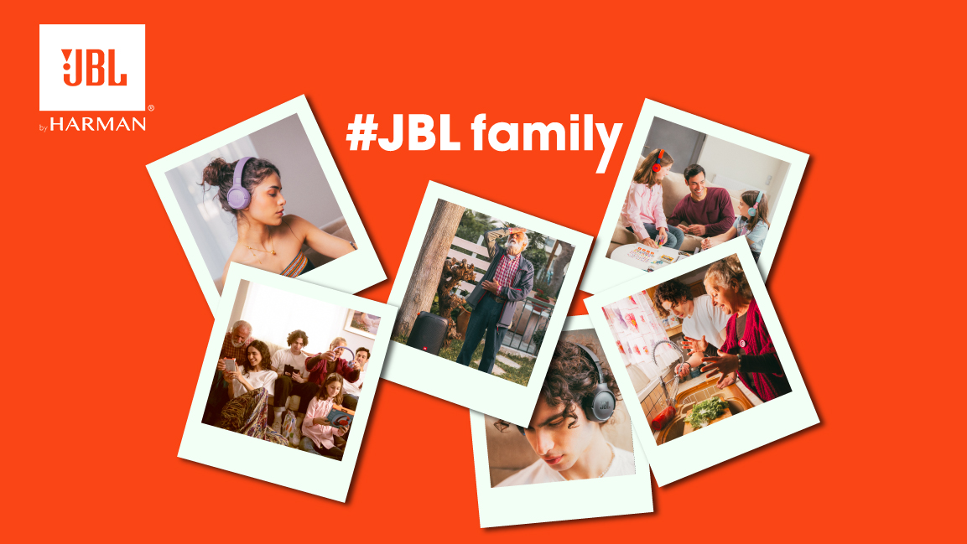

What connects a traditional Greek family to the JBL product family? JBL's new Easter campaign created by Veesion - Your Creative Partner.

Athens , April 2023- The campaign is based on 2 insights: The first insight is that JBL family includes a variety of audio products: bluetooth speakers, soundbars, partyboxes, products for gamers and headphones with the most innovative technologies. This, after all, is why everyone loves JBL… young and old. The second insight is that JBL products appeal to many different age target groups : Soundbars bring the family together in front of the TV, partyboxes level up the party and entertain kids, teenagers, parents and grandparents all together.

Through a series of 20 videos, we watch a family travel to the village and enjoy the traditional Greek Easter with the best company, JBL products. We watch their preparation: Son helps his father to load Partybox 310 in the car. Mum put in her bag her tws headphones and her daughter prepare her suitcase without forgetting her favorite speaker.
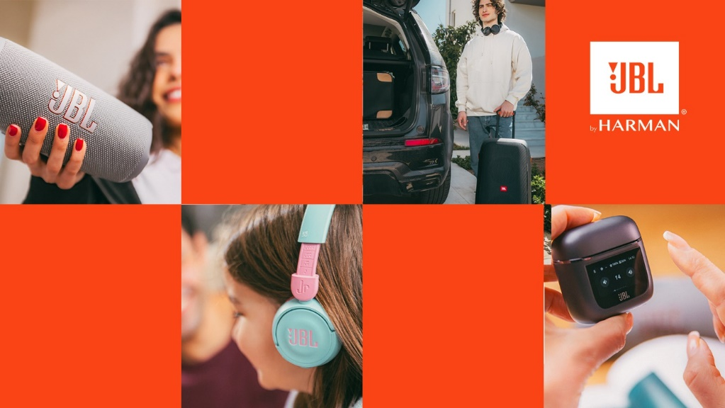

The family starts its roadtrip to the village. The kids have their headphones enjoying their favorite playlists during the trip. Before they arrive in their home in village, they met a friend who is jogging with his sport true wireless headphones. When they arrive they meet grandfather who has already a partybox speaker. Grandmother with her grandchildren do all the necessary preparations for Easter table and godfather gives to his godchild her candle and her gift- junior headphones. Sunday Easter they all together dancing and singing traditional Greek songs.
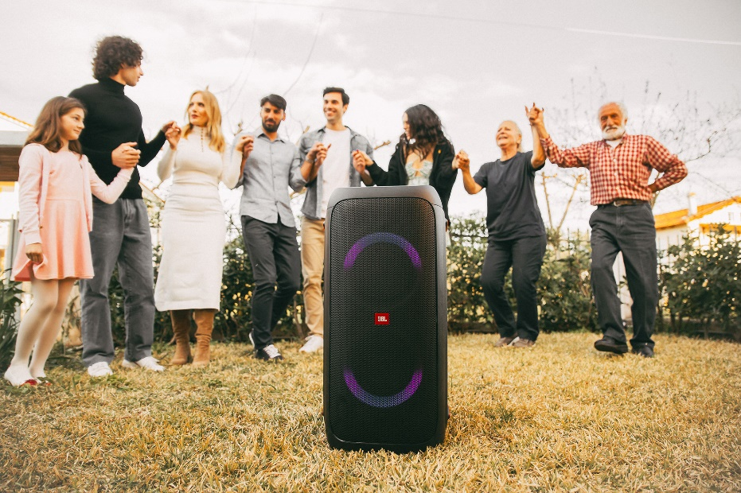

For more info visit:
Home | JBL (jblgreece.gr)
@jbl_greece
JBL Greece
jbl_greece

Agency: Veesion
Production: Veesion
Videography/Photography: Rise Productions gr
Models: Sons And Daughters MGT
Sound: Soundslike

About WaveMotion
WaveMotion, an importer and distributor, is seated in Athens Greece, operating on a wholesale basis, in the consumer electronics, telecommunications and computer industry for over 35 years. WaveMotion S.A. retains the official, exclusive, distribution for the Greek market of important Houses- in leading positions in the Global Arena, like JBL, harman/kardon, Cambridge Audio, Q Acoustics, QED, Goldring, rapoo, Native Union, Livall. Brand Development is the core skill of WaveMotion Team. The vision of our people is to expand WaveMotion’s Brands selection, following our tagline’s principles –Technology, Aesthetics, Design- and continue this journey of Ours, introducing compellingly and establishing decisively these Brands, in the eyes of our customers.
About VEESION (www.veesion.gr)
The independent advertising company VEESION was created in 2020 during the lockdown. Open to challenges and collaborations, it is a creative partner to companies in Greece and the United Arab Emirates, offering integrated communication services: Advertising, Branding, Digital & social media, Brand Experience, Video Content, Guerrilla & Growth Hacking Marketing. VEESION constantly invests in talented people with exceptional character, in new technologies and in training. VEESION's DNA consists of 4 main elements: Innovation, creativity, empathy and efficiency.
About HARMAN
HARMAN (harman.com) designs and engineers connected products and solutions for automakers, consumers, and enterprises worldwide, including connected car systems, audio and visual products, enterprise automation solutions; and services supporting the Internet of Things. With leading brands including AKG®, Harman Kardon®, Infinity®, JBL®, Lexicon®, Mark Levinson® and Revel®, HARMAN is admired by audiophiles, musicians and the entertainment venues where they perform around the world. More than 50 million automobiles on the road today are equipped with HARMAN audio and connected car systems. Our software services power billions of mobile devices and systems that are connected, integrated and secure across all platforms, from work and home to car and mobile. HARMAN has a workforce of approximately 30,000 people across the Americas, Europe, and Asia. In March 2017, HARMAN became a wholly owned subsidiary of Samsung Electronics Co., Ltd...

