For more information: Press Release
JBL Greece ( Official Distributor WaveMotion S.A) For direct publication.
Tel.:210-9244505 Date:08/02/23
Email: jbl_greece@wavemotion.gr
You + Martin Garrix = The ultimate
JBL Snow Party experience
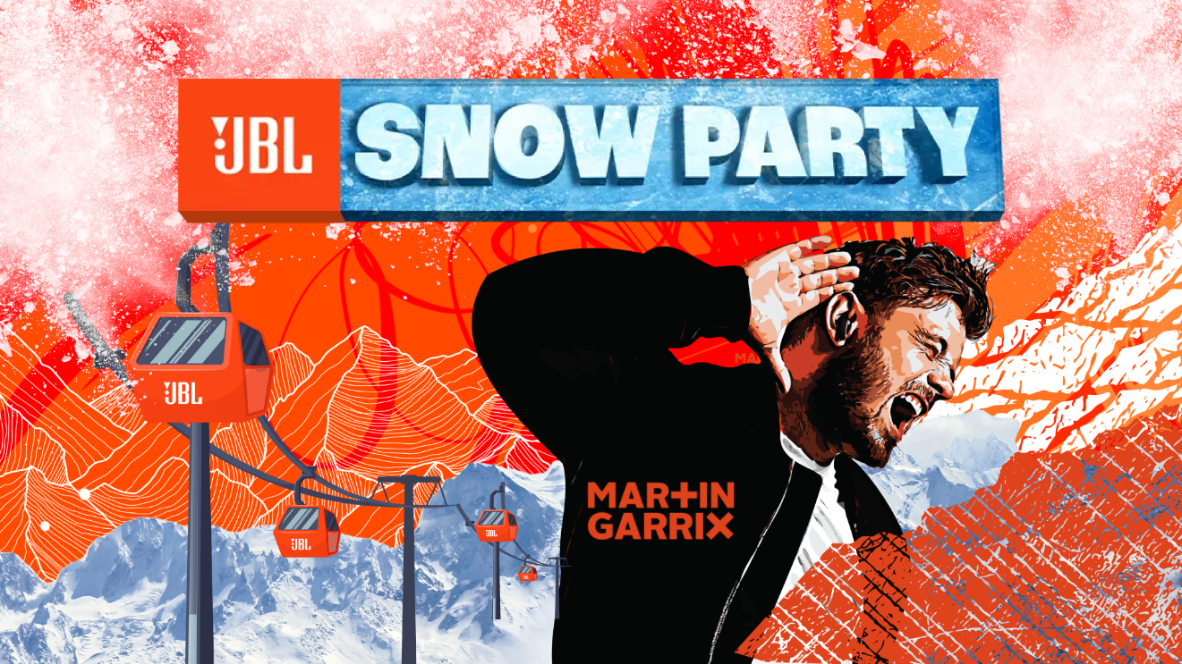

JBL Snow Party is back! JBL and Kotsovolos travels you in Val Thorens, France from April 20 to 23 for a newer and bigger party!

Expect pure joy in the mountains where you can meet people from around the world for 3 days of music, sports, inspiration, and a whole lot of fun!

Do you want to win a double ticket to the biggest ever party in the Alps?
The steps are simple:
- Shop JBL from Kotsovolos in Greece or Kotsovolos in Cyprus!
- Sign up here and you are ready!*
*Do not forget to maintain your receipt for the final confirmation.
The contest period starts on February 3rd, 2023 and ends on March 5th , 2023

You will choose your partner and JBL will offer you:
✅Two round trip economy-class airfares to/from the destination airport
✅Three nights’ hotel accommodations (all inclusive) in one double room at Club Med Val Thorens Sensations hotel in Val Thorens, France.
✅Ground transportation to and from hotel/Geneva airport or Lyon airport
✅Food and beverage provided
✅Ski hire for April 21st, 2022 – April 23rd, 2023;
✅Entrance to Exclusive Parties
✅Meet Martin Garrix and other famous artists

Who is gonna be your partner? This is the only thing you have to think about!

Looking for more? We've got inspiring sessions for you to learn from and activities to keep you busy - or just join us to find out!

COMMUNITY
Every year, JBL unites hundreds of people from all over Europe in the mountains for a Snow Party of a lifetime. Think friends old and new, coming together for music and more that inspires. Will you be one of them?
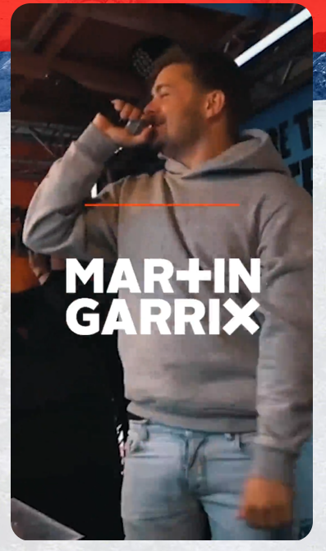

MUSIC
We've lined up a unique spread of music for everyone across different venues, so you can party to world famous DJs such as Martin Garrix and more. The program continues around the Val Thorens resort with up and coming artists, so you'll have music that just keeps going on and on. Stay posted on our line-up!

ACTIVITIES
We're out to keep you entertained, so you'll find a variety of activities at Snow Party. From slopes for pro athletes to classes for newbies, everyone of every winter sport level is welcome. There's also ice skating, climbing, and apres-ski parties - quite literally something for everyone! Get ready for the biggest ever party in the Alps with JBL and Μartin Garrix!

NATURE
Val Thorens is located in the heart of The Three Valleys within the Savoie region of France. It's the highest resort in Europe with an altitude of 2,3000m with good snow guaranteed from November till May.

Are you ready for the biggest ever Snow Party in Alps?

Discover more at:
Home | JBL (jblgreece.gr)
@jbl_greece
JBL Greece

About WaveMotion
WaveMotion, an importer and distributor, is seated in Athens Greece, operating on a wholesale basis, in the consumer electronics, telecommunications and computer industry for over 35 years. WaveMotion S.A. retains the official, exclusive, distribution for the Greek market of important Houses- in leading positions in the Global Arena, like JBL, harman/kardon, Cambridge Audio, Q Acoustics, QED, Goldring, rapoo, Native Union, Livall. Brand Development is the core skill of WaveMotion Team. The vision of our people is to expand WaveMotion’s Brands selection, following our tagline’s principles –Technology, Aesthetics, Design- and continue this journey of Ours, introducing compellingly and establishing decisively these Brands, in the eyes of our Customers.
About VEESION (www.veesion.gr)
The independent advertising company VEESION was created in 2020 during the lockdown. Open to challenges and collaborations, it is a creative partner to companies in Greece and the United Arab Emirates, offering integrated communication services: Advertising, Branding, Digital & social media, Brand Experience, Video Content, Guerrilla & Growth Hacking Marketing. VEESION constantly invests in talented people with exceptional character, in new technologies and in training. VEESION’s DNA consists of 4 main elements: Innovation, creativity, empathy and efficiency.

About HARMAN
HARMAN (harman.com) designs and engineers connected products and solutions for automakers, consumers, and enterprises worldwide, including connected car systems, audio and visual products, enterprise automation solutions; and services supporting the Internet of Things. With leading brands including AKG®, Harman Kardon®, Infinity®, JBL®, Lexicon®, Mark Levinson® and Revel®, HARMAN is admired by audiophiles, musicians and the entertainment venues where they perform around the world. More than 50 million automobiles on the road today are equipped with HARMAN audio and connected car systems. Our software services power billions of mobile devices and systems that are connected, integrated and secure across all platforms, from work and home to car and mobile. HARMAN has a workforce of approximately 30,000 people across the Americas, Europe, and Asia. In March 2017, HARMAN became a wholly-owned subsidiary of Samsung Electronics Co., Ltd..

