For more information: Press Release
WaveMotion S.A For direct publication
Τηλ.:210-9244505 Hμ.:
Email: Partners@WaveMotion.gr

NATIVE UNION
Creates solutions for the modern lifestyle of Apple Users
Now in WaveMotion’s Lifestyle Technology portfolio of Brands

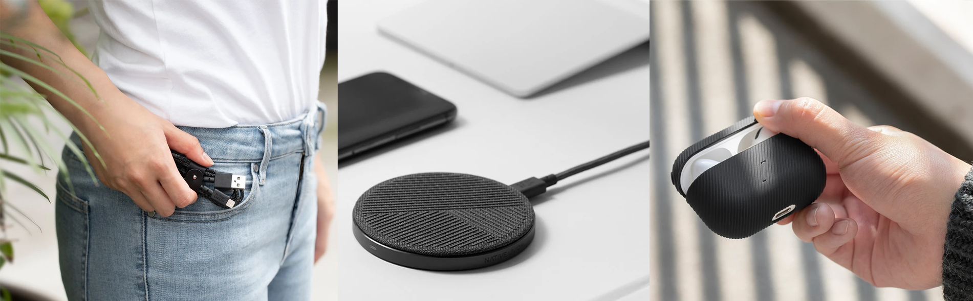

Athens, November 2021. – WaveMotion SA announces the official distribution for Greece of NATIVE UNION, enhancing further its Lifestyle Technology Brands portfolio.

Born out of a shared love of good design & quality products, NATIVE UNION creates considered solutions fit for users’ modern lifestyle, offering unique accessories for their Apple devices. Always driven by passion, NATIVE UNION’s team focuses on 3 main pillars: enhanced user experience, innovation through design and a dedication to using the highest quality materials.
10 years ago, John and Igor met at a co-working space in Hong Kong. Sharing a passion for good design and quality products, they set out to challenge the perception that tech accessories are purely functional and uninspired. Together, they created NATIVE UNION.
A decade later, they're now an international team with offices in Hong Kong, Paris, and Los Angeles, crafting everyday solutions for an audience just as global. While people may think NATIVE UNION simply making beautiful tech accessories, their ambition is really to empower the modern lifestyle that's become due to technology – one in which being on-the-go is the norm and flexibility of time and place to focus on what's important to us is priority. Creating products that support this new way of life with enhanced functionality and refined style, they hope to give people the confidence to pursue their own passions.

NATIVE UNION’s Collection includes

Cables, Wireless Chargers & Airpod Cases.

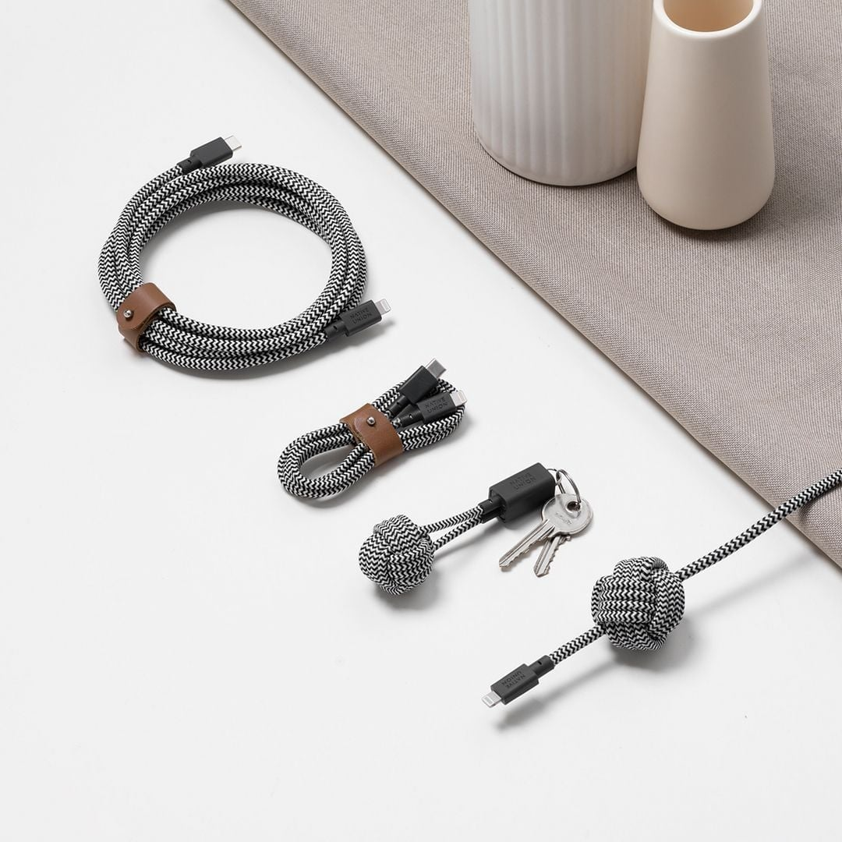Cables
Presenting a range of high quality cables that meet the demands of our individual lifestyles, and look good doing it. Innovative thinking and functional design that anticipate all your daily charging needs. The range includes Key cables, Belt cables and Belt cables universal.
Key cable attaches to your keys so it’s always with you. Its hidden connectors give you peace of mind that you’ll always have the tools to recharge. Belt Cable puts an end to tangled-up cables at the bottom of your bag. Fitted with an integrated genuine leather strap, it’s smart, tangle-free and durable. With its 3-in-1 Micro-USB to Lightning or USB-C connector, Belt Cable Universal can be used to conveniently charge all your devices at home or on-the-go. For more information: Smartphone & Tablet USB Cables - Wavemotion S.A.

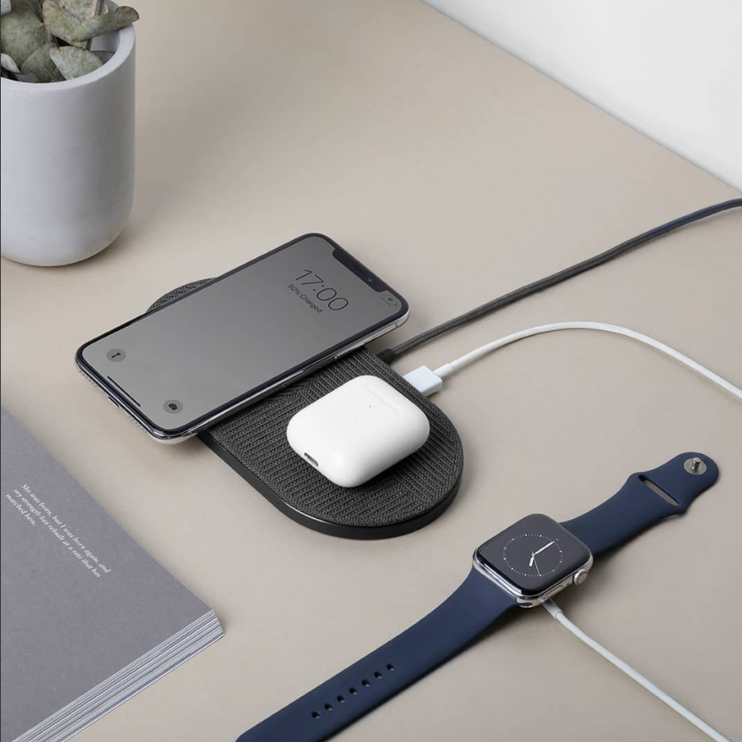Wireless Chargers
With their sleek and minimal form, the family of wireless chargers have been designed to withstand time and offer maximum versatility when recharging and using your devices. Wireless Chargers are consisted of Drop Wireless Charger, Drop XL Wireless Charger & Drop XL Wireless Charger Watch Edition. Fast and secure charging for iPhone & Qi enabled devices* .
Drop Wireless Charger designed with an ultra-thin aluminum base, foreign object detection, and thermal protection to ensure durability and safe charging, every time. Drop XL Wireless Charger power 3 devices at once with this multi-device wireless charging pad fitted with one additional USB-A port. A striking combination of hard-wearing home textile and aircraft grade aluminum makes addition to your home or workspace. From your iPhone, to AirPods, to Apple Watch. With Drop XL Wireless Charger Watch Edition you can reduce clutter around your home, or workspace with this multi-device charging pad with detachable Apple Watch charging puck. For more information: Wireless Chargers Archives | WaveMotion S.A. (*up to 10W for Qi enabled devices)

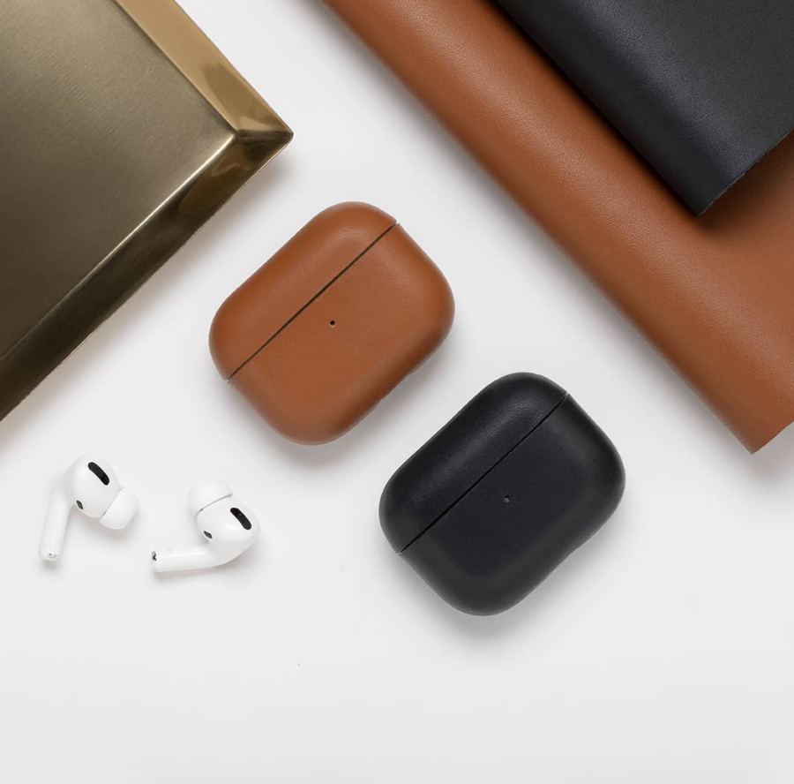Airpods Cases
Discover our brand-new range of protection for AirPods, crafted with premium materials in thoughtfully selected color palettes. The airpods cases range include Curve Cases, Roam Cases & Leather Cases.
Curve case is designed for the minimalist. Crafted in a sleek silicone and finished with textured ridges for grip, this case adds style and protection to your everyday carry while retaining full functionality. Roam case offers a lightweight and form-fitting protection for your AirPods Pro, crafted with a minimalist design in silky liquid silicone. A smooth matte finish provides non-slip grip. Attach the case to your bag or belt for effortless carry with the attached sleek matte aluminum clip. And Leather case, handcrafted with Italian leather for refined protection that will age beautifully over time, provides a seamless fit & tactile feel to your AirPods. For more information: Cases for Airpods Archives | WaveMotion S.A.

You can find NATIVE UNION’s Collection of Cables, Wireless Chargers and Airpod Cases, now in Authorized Resellers offering various price levels for all tech users. For more information: NATIVE UNION | WaveMotion S.A.

About WaveMotion
WaveMotion, an importer and distributor, is seated in Athens Greece, operating on a wholesale basis, in the consumer electronics, telecommunications and computer industry for over 35 years. WaveMotion S.A. retains the official, exclusive, distribution for the Greek market of important Houses- in leading positions in the Global Arena, like JBL, harman/kardon, Cambridge Audio, Q Acoustics, QED, Goldring, rapoo, NATIVE UNION, Livall. Brand Development is the core skill of WaveMotion Team. The vision of our people is to expand WaveMotion’s Brands selection, following our tagline’s principles –Technology, Aesthetics, Design- and continue this journey of Ours, introducing compellingly and establishing decisively these Brands, in the eyes of our Customers.

ABOUT NATIVE UNION:
NATIVE UNION is an award-winning product design company bringing a unique and sophisticated perspective to the booming mobile accessories market. Founded in 2009 by John Brunner and Igor Duc, NATIVE UNION creates tech accessories with inherent warmth, personality and individuality, through its dedication to sophisticated design, innovative materials and an obsession with details. NATIVE UNION’s in-house design team focuses on 3 main pillars: enhanced user experience, innovation through design and a dedication to using the highest quality materials. Garnering considerable critical acclaim from the design community, NATIVE UNION has offices in Los Angeles and Hong Kong with product available in the finest retailers across the world.

