For more information: Press Release
WaveMotion S.A For direct publication
Τηλ.:210-9244505 Hμ.:
Fax: 211-0123494
Email: Partners@WaveMotion.gr
The Cambridge Audio Evo is a stunning all-in-one audio system, designed in London

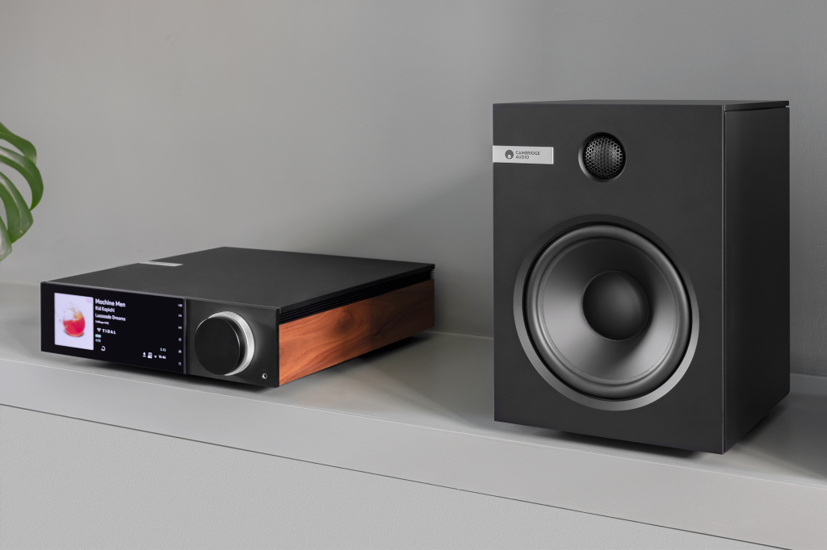

Evo by Cambridge Audio is a beautifully designed all-in-one music player that gives you instant access to all the music in the world. Cambridge Audio has been at the forefront of British audio innovation for over 50 years and Evo represents an evolution in hi-fi: an all-in-one music player that combines timeless design, cutting edge technology, streaming smarts, and incredible audio performance into one streamlined and compact box.

Minimal, timeless design
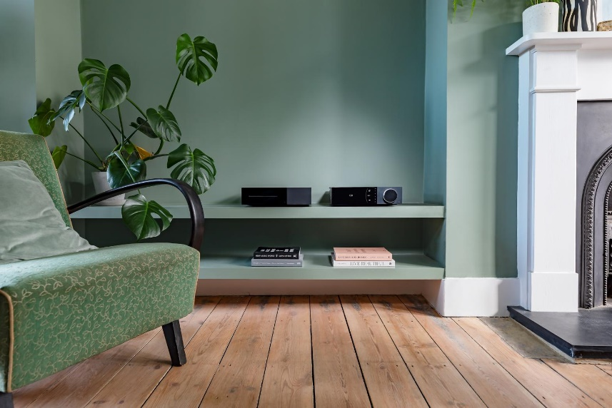
Designed in Cambridge Audio’s London studio, Evo’s minimal and timeless aesthetic will fit into any interior and lifestyle. Lead designer Ged Martin chose premium materials and used industrial design principles to create a product that champions simplicity and will endure for many years. Taking inspiration from the wood trims of the iconic P40, Cambridge Audio’s first ever product from 1968, Evo has beautiful walnut wood side panels that complement the sleek, black anodised aluminium cabinet. Evo also comes with a choice of formed black side panels made from Richlite, an innovative new material made primarily from recycled paper. The side panels can be switched out according to each customer’s style. Completing Evo’s elegant design is a dual-concentric rotary dial and large 6.8in LCD display panel that shows off album artwork in full colour.
High quality hi-fi sound
Over five decades of Cambridge Audio’s sound and design expertise is distilled into one piece of hi-fi: Evo. In the company’s London headquarters, a team of talented engineers spent hundreds of hours listening to Evo and tuning it to perfection. All to ensure Evo delivers an extraordinarily enjoyable sound performance – no matter what you’re listening to. Evo uses high quality components and is powered by a revolutionary Hypex NCore® Class D amplification, which reproduces every detail in your music while remaining compact and energy efficient. Evo comprises two models: Evo 150 is rated at 150 watts per channel, and Evo 75 has 75 watts per channel. The Hypex NCore® power module was specifically chosen by Cambridge Audio’s engineers as it offers class-leading audio performance and produces clear advantages in clarity, resolution and musicality. It’s a big part of what makes Evo such an enjoyable listen.

Optimised for streaming
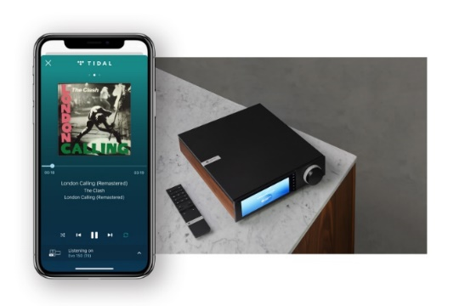
At the heart of Evo lies Cambridge Audio’s powerful StreamMagic platform. It’s designed to be the best-sounding streaming platform around and supports the latest digital music formats and services. Both Evo models use powerful ESS Sabre DACs to ensure all digital music is converted to analogue sound with every ounce of detail, precision and dynamics intact. Whether you use Roon to organise your digital library or stream high-resolution MQA tracks using TIDAL Connect – Evo can play it all. And StreamMagic will ensure you that hear your music in the best possible sound quality, no matter where you’re playing it from and in whatever source quality. Evo supports streaming using a variety of methods, including AirPlay 2, Bluetooth, Chromecast built-in, Qobuz, Roon Ready, Spotify Connect, Tidal Connect and internet radio. Using the Evo couldn’t be simpler, with the StreamMagic app offering comprehensive control over Evo. With the app, you have access to all your favourite streaming services at the tap of a button. You can use the app or the included remote to easily switch between inputs and play all your music from every connected source. Software updates and new features can be added remotely using the StreamMagic app, so you can be sure that Evo is always evolving and will be at the cutting edge of streaming technology.

“Evo is the product we’ve been leading up to for over 50 years.”

Stuart George, Managing Director, Cambridge Audio, said: “At Cambridge Audio, we think evolution is about even more than improving the quality of the sound you hear and enhancing your enjoyment of music. Evolution is also about transforming the convenience and usability of hi-fi without compromising its performance. Evolution is about bringing hi-fi into the future, making it fit your lifestyle, and ensuring it looks just as good as it sounds.
Evo 75 and Evo 150 are available now in Authorized Resellers for 1.199,00€ and 2.499,00€. More information can be found at Cambridge Audio® | WaveMotion A.Ε.

About WaveMotion
WaveMotion, an importer and distributor, is seated in Athens Greece, operating on a wholesale basis, in the consumer electronics, telecommunications and computer industry for over 35 years. WaveMotion S.A. retains the official, exclusive, distribution for the Greek market of important Houses- in leading positions in the Global Arena, like JBL, harman/kardon, Cambridge Audio, Q Acoustics, QED, Goldring, rapoo, Native Union, Livall. Brand Development is the core skill of WaveMotion Team. The vision of our people is to expand WaveMotion’s Brands selection, following our tagline’s principles –Technology, Aesthetics, Design- and continue this journey of Ours, introducing compellingly and establishing decisively these Brands, in the eyes of our Customers.

About Cambridge Audio
Since Cambridge Audio released its iconic P40 amplifier in 1968 they have pursued one simple objective: to produce audio equipment that faithfully creates a pure and natural sound. At Cambridge Audio, they are sold on the unfiltered, unadulterated ‘British Sound’. They believe it’s simply the purest and most faithful reproduction of whatever you’re listening to, so you hear music exactly the way its creators wanted it to sound. They achieve this by identifying the best possible components before carefully fine-tuning how they put them together. Put simply, they use their expertise to remove the barriers between you and your music. Nothing added, nothing taken away. They actively encourage press and consumer reviews of all our products and they’re proud that Cambridge Audio products are consistently recognised for their outstanding performance, innovation and value.

