For more information Press Release
WaveMotion Α.Ε. FOR IMMEDIATE PUBLICATION
Τηλ.:210-9244505 Hμ.: 1/11/2019
Fax: 211-0123494
Email: Partners@WaveMotion.gr

JBL Sport Headphones @ ERGO MARATHON EXPO 2019

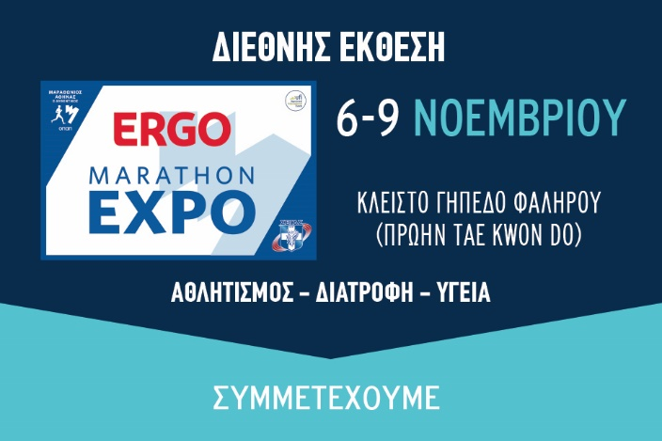
WaveMotion Α.Ε., official distributor of lifestyle offerings of JBL, will participate for the second year in the row, at ERGO MARATHON EXPO exhibition. The ERGO Marathon Expo, which is conducted parallel to the Athens Authentic Marathon is a unique sports and shopping festival, where participants and guests of the Marathon and all athletes can be informed and get acquainted with products and services in the sports industry.
During the Show, Athletes and Guests will be presented with the new, updated range of JBL Sport Headphones. JBL Sport Headphones are ergonomic, comfortable to wear but most of all, they deliver the legendary JBL Sound. Wired or Wireless, with reflect, sweatproof cables and heart rate monitor, choose your own model out of a great range.
WaveMotion will present 2 new of JBL Sport Headphones, JBL ENDURANCE PEAK & JBL UA WIRELESS SPORT TRAIN. At ERGO MARATHON EXPO exhibition you can visit WaveMotion’s kiosk to try them for the very first time!
JBL ENDURANCE PEAK Headphones are totally waterproof and enable you to enjoy the freedom of a fully wireless workout without the need to recharge the headphones for as long as 28 hours. But if you feel like you still have more to give, it only takes 10 minutes of recharging for another hour of motivating music. Thanks to the PowerHook™ technology, the JBL Endurance PEAK headphones conveniently power on and off as you start wearing them, so they’re ready to attack each workout whenever you are. In addition, the JBL Endurance PEAK headphones work in both mono and stereo mode and allow you to seamlessly control your sound or calls directly on the earpiece using their convenient touch controls.
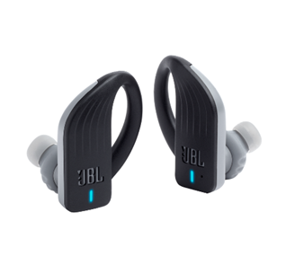
Features:
- Truly wireless
- 28 hours of combined playback
- PowerHook™ Never hurt. Never fall out.
- Waterproof Touch controls (IPX7 Rate)
- Mono and Stereo Mode
- Hands-free calls
- Quick charge Technology (10’/ 1h Playback)

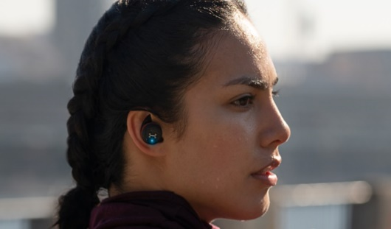
UA True Wireless Flash offers a truly cord-free experience to push yourself further. The UA waterproof technology and Sport Flex Fit ear tips were crafted specifically for all condition training while the JBL Charged Sound was boldly optimized and tuned for motivation. Hear your surroundings with Bionic Hearing featuring TalkThru Technology to quickly interact with your workout partner, and AmbientAware Technology to hear your surroundings for increased safety.

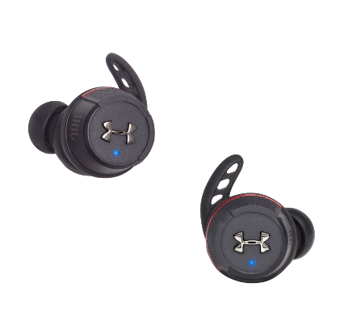
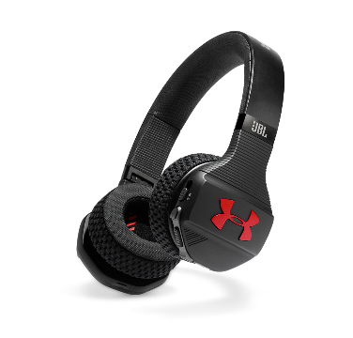
Features
- Truly Wireless for Sport
- Waterproof, High-Performance
- Design for Sport Bionic Hearing
- JBL Charged Sound
- 25 Hours of total battery life
- Bluetooth® wireless
- Sport Flex Fit ear tips
- Aluminum Charging case

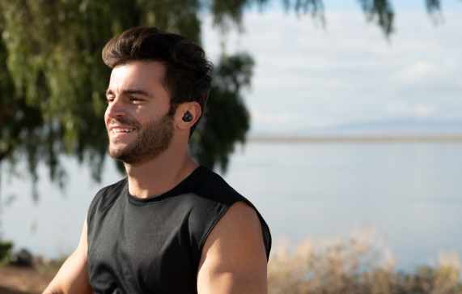
JBL Reflect Flow are comfortable and secure thanks to customizable ear-tips and Freebit enhancers, the Reflect Flow headphones deliver powerful JBL Signature Sound designed for movement. The Reflect Flow headphones are IPX7 water and sweat proof providing 10 hours of continuous playtime with 20 additional hours in the charging case. In addition, Reflect Flow offer the ability to change tracks, manage calls hands-free and access your voice assistant. You’ll also enjoy the Ambient Aware feature that enables you to hear what’s happening around you while still enjoying your music. Additionally, the TalkThru feature allows you to have a conversation without taking off the headphones.
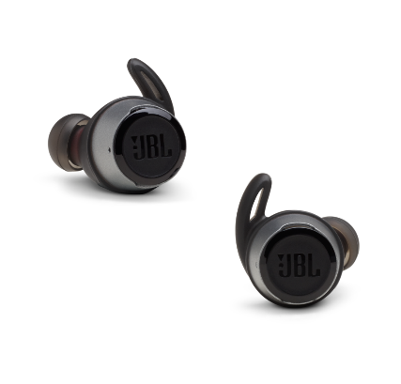
Features
- Truly Wireless
- Hands-free stereo calls with easy access to your voice assistant
- Ambient Aware and TalkThru
- Waterproof
- 30 Hours Battery Life + Speed Charge
- JBL Signature Sound
- Ergonomic Fit

Pricing and Availability
JBL Endurance Peak and JBL Reflect Flow are available from November 2018 at the suggested retail price of 149€ and JBL|UA Sport Wireless Flash at the suggested retail price of 179€.
For more information, contact WaveMotion S.A., official distributor of Harman Lifestyle Division by calling 210-9244505 or visit: www.wavemotion.gr & eu.jbl.com.
The brand names harman/kardon®, JBL® και Infinity® belong to Harman International Industries.

About WaveMotion
WaveMotion, an importer and distributor, is seated in Athens Greece, operating on a wholesale basis, in the consumer electronics, telecommunications and computer industry for over 35 years. WaveMotion S.A. retains the official, exclusive, distribution for the Greek market of important Houses- in leading positions in the Global Arena.
Brand Development is the core skill of WaveMotion Team. The vision of our people is to expand WaveMotion’s Brands selection, following our tagline’s principles –Technology, Aesthetics, Design- and continue this journey of Ours, introducing compellingly and establishing decisively these Brands, in the eyes of our Customers.

