For more information: Press Release
WaveMotion Α.Ε. For immediate release
Phone:210-9244505
Fax: 211-0123494
Email: Partners@WaveMotion.gr

WaveMotion at IMAGE+TECH - PHOTOVISION

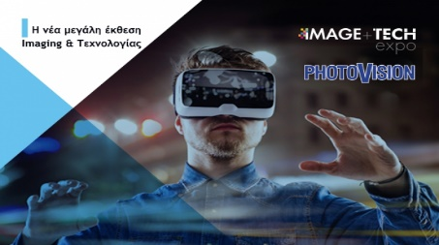
WaveMotion S.A., official distributor for lifestyle offerings of JBL is participating for the first time in the largest and longest-running Imaging and Technology exhibition in the country, joined forces under the auspices of SEKAF, aiming to create a technology and imaging systems exhibition, as imagined by our country's broader imaging industry. The exhibition will be held at HELEXPO MAROUSSI from 5 to 7 April 2019.
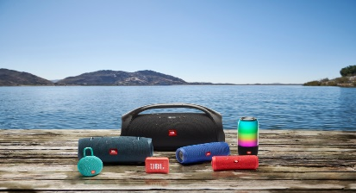
During IMAGE TECH-Photovision 2019, WaveMotion S.A. will demonstrate all new offerings from JBL 2018/2019 season in a booth full of surprises and summer vibes. Portable Bluetooth Waterproof Speakers, Lifestyle and Sport Headphones incorporating the latest technologies, will create a unique atmosphere of live enjoyment for the visitors and technology enthusiasts.
For more information about the exhibition click here.
The brand names harman/kardon, JBL και Infinity belong to Harman International Industries.
About WaveMotion
WaveMotion, an importer and distributor, is seated in Athens Greece, operating on a wholesale basis, in the consumer electronics, telecommunications and computer industry for over 35 years. WaveMotion S.A. retains the official, exclusive, distribution for the Greek market of important Houses- in leading positions in the Global Arena.
Brand Development is the core skill of WaveMotion Team. The vision of our people is to expand WaveMotion’s Brands selection, following our tagline’s principles –Technology, Aesthetics, Design- and continue this journey of Ours, introducing compellingly and establishing decisively these Brands, in the eyes of our Customers.

