**For more information Press Release**

**WaveMotion Α.Ε. FOR IMMEDIATE PUBLICATION**

Τηλ.:210-9244505 Hμ.: 1/11/2018

Fax: 211-0123494

Email: [Partners@WaveMotion.gr](mailto:Partners@WaveMotion.gr)

***Legendary Sound for a Legendary Marathon.***

***JBL Sport Headphones will motivate again, the Athens Authentic Marathon exhibition***

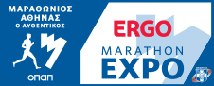**WaveMotion** Α.Ε., official distributor of lifestyle offerings of JBL, will participate for the second year in the row, at ERGO MARATHON EXPO exhibition. The ERGO Marathon Expo, which is conducted parallel to the Athens Authentic Marathon is a unique sports and shopping festival, where participants and guests of the Marathon and all athletes can be informed and get acquainted with products and services in the sports industry.

During the Show, Athletes and Guests will be presented with the new, updated range of JBL Sport Headphones. JBL Sport Headphones are ergonomic, comfortable to wear but most of all, they deliver the legendary JBL Sound. Wired or Wireless, with reflect, sweatproof cables and heart rate monitor, choose your own model out of a great range.

**WaveMotion** will present 2 new of JBL Sport Headphones, **JBL ENDURANCE PEAK & JBL UA WIRELESS SPORT TRAIN**. At ERGO MARATHON EXPO exhibition you can visit **WaveMotion’s** kiosk to try them for the very first time!

**JBL ENDURANCE PEAK Headphones** are totally waterproof andenable you to enjoythe freedom of a fully wireless workout without the need to recharge the headphones for as long as 28 hours. But if you feel like you still have more to give, it only takes 10 minutes of recharging for another hour of motivating music. Thanks to the PowerHook™ technology, the JBL Endurance PEAK headphones conveniently power on and off as you start wearing them, so they’re ready to attack each workout whenever you are. In addition, the JBL Endurance PEAK headphones work in both mono and stereo mode and allow you to seamlessly control your sound or calls directly on the earpiece using their convenient touch controls.

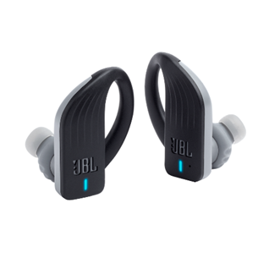**Features:**

* Truly wireless
* 28 hours of combined playback
* PowerHook™ Never hurt. Never fall out.
* Waterproof Touch controls (IPX7 Rate)
* Mono and Stereo Mode
* Hands-free calls
* Quick charge Technology (10’/ 1h Playback)

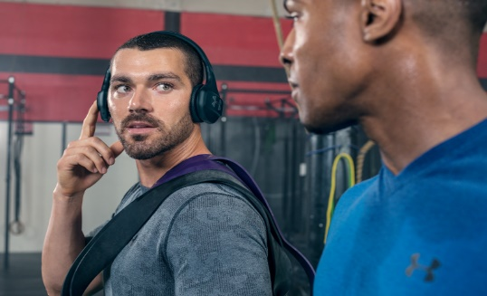JBL **UA SPORT WIRELESS TRAIN** are built for the gym. SuperVent ear cushions keep them cool and dry while Under Armour grip material provides a soft feel and maximum stability. UA Train headphones elevate every rep with big, wireless JBL Charged Sound and all-new Bionic Hearing with TalkThru Technology. With a simple touch of the UA logo, TalkThru Technology is enabled so you can talk to your training partner or coach without having to remove the headphones.

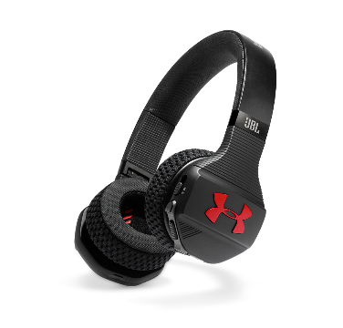**Features**

* Under Armour Fabric Technology
* 16-hour Speed Charge battery
* Bionic Hearing
* Bluetooth® wireless
* JBL Charged Sound
* Oversized controls
* Rugged durability
* Compact Transpor

**Pricing and Availability**

JBL Endurance Peak is available from November 2018 at suggested retail price of 149€ and JBL|UA Sport Wireless Train at the suggested retail price of 199€.

For more information, contact WaveMotion S.A., official distributor of Harman Lifestyle Division by calling [210-9244505](tel:+302109244505)or visit: [www.wavemotion.gr](http://www.wavemotion.gr/)& [eu.jbl.com](http://eu.jbl.com/).

The brand names harman/kardon®, JBL® και Infinity® belong to Harman International Industries.

**About WaveMotion**

WaveMotion, an importer and distributor, is seated in Athens Greece, operating on a wholesale basis, in the consumer electronics, telecommunications and computer industry for over 35 years. WaveMotion S.A. retains the official, exclusive, distribution for the Greek market of important Houses- in leading positions in the Global Arena.

Brand Development is the core skill of WaveMotion Team. The vision of our people is to expand WaveMotion’s Brands selection, following our tagline’s principles –Technology, Aesthetics, Design- and continue this journey of Ours, introducing compellingly and establishing decisively these Brands, in the eyes of our Customers.