For more information: Press Release
WaveMotion S.A For direct publication
Tel.:210-9244505 Date.: 28/03/2023
Fax: 211-0123494
Email: Partners@WaveMotion.gr

LIVALL @ Athens Bike Festival
at the biggest event of the bicycle

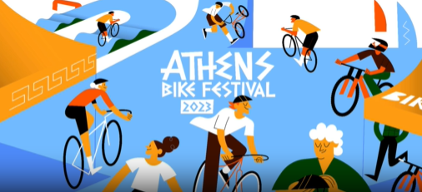

Athens, March 28th, 2023. -WaveMotion Α.Ε., official distributor of LIVALL Smart Helmets announces its participation at Athens Bike Festival

Athens Bike Festival started 12 years ago, with the first event in Technopolis for 8 consecutive years. The main goal of Athens Bike Festival since the first year of its creation, back in 2010, was to gather all fans of cycling, in an event - a celebration, for the bicycle itself! Athletes, amateurs, simple bike lovers, children, everyday citizens are interested in alternative means of transportation – everyone who is interested in the bicycle in any form, has one thing in common: the bicycle! Gathering more than 35,000 visitors every year, the Athens Bike Festival highlights the joy of cycling, the simplicity, convenience and practicality that characterize the means of transportation. In 2023, after a three-year absence due to the pandemic, the Athens Bike Festival changes and evolves. It proposes a new concept, new place and date and comes renewed to confirm the bicycle as the favorite hobby, sport and mean of transportation for thousands of Greeks.

During the Festival, WaveMotion will proudly present LIVALL, world's first smart and safety cycling helmet brand. LIVALL is the leading pioneer in the smart helmet industry, offering the most forward-thinking and advanced technologies available on the market. LIVALL emphasizes in safety and technology and takes a sophisticated approach to its helmets through continual R&D, and by considering the impact its products have on consumers and the planet. Visitors of Athens Bike Festival will have the chance to visit WaveMotion’s kiosk and try LIVALL ‘s offerings!

LIVALL Products Range

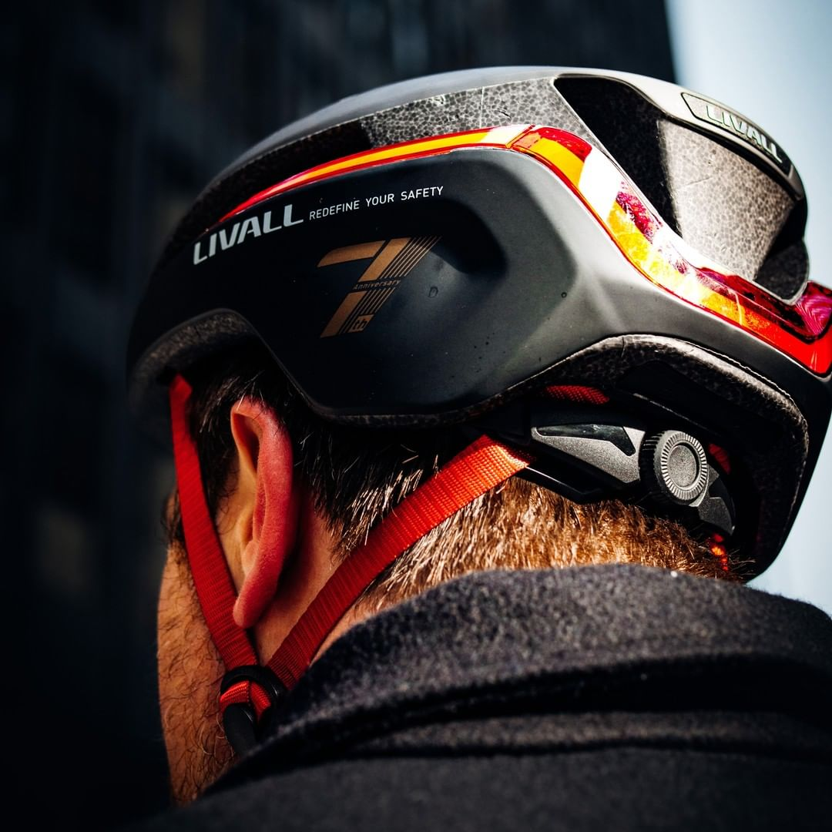
ΕVO 21 is the crowning achievement of LIVALL. It’s time to take your helmet even further. It is the smartest lighting helmet in the world that will ‘redefine your safety' and for better. The LIVALL EVO21 has been designed based on 3 core principles- Brighter, Lighter, and Safer. Other brands claim to give you 360° visibility, but they often fall short. The LIVALL EVO21 Smart Helmet offers true 360° coverage, with a brake warning light and turn signals for visibility from all directions. Plus, 3 dynamic light effects will make you hard to miss on the road, you can ride with your peace of mind as well as ride in style. With 30% more ventilation and 350g lightweight design, you’ll stay ahead of the pack while cutting down on sweat with the LIVALL EVO21 Smart Helmet. The LIVALL EVO21 Smart Helmet features patented fall detection and SOS technology. So in the event of a fall it sends a text message alert to your emergency contact with your exact GPS location.

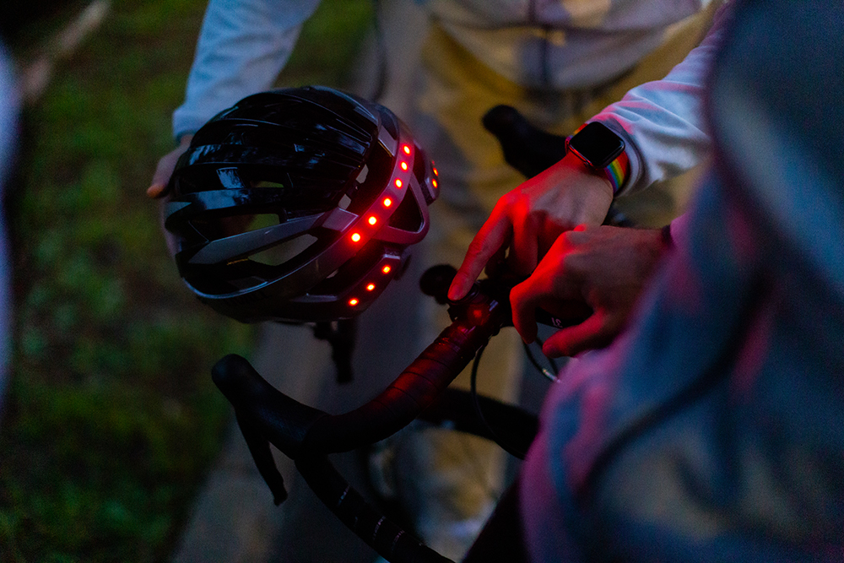
The best helmet to experience the thrill of the wild is the LIVALL MT1 Neo Mountain Bike Smart model, a multifunctional lightweight smart helmet that combines safety with connectivity. It has many high-tech features that makes it perfect for the cyclist who like to go off the road. Some of them are: LED safety lights, handlebar remote control, stereo speakers and Bluetooth technology to connect your smartphone.

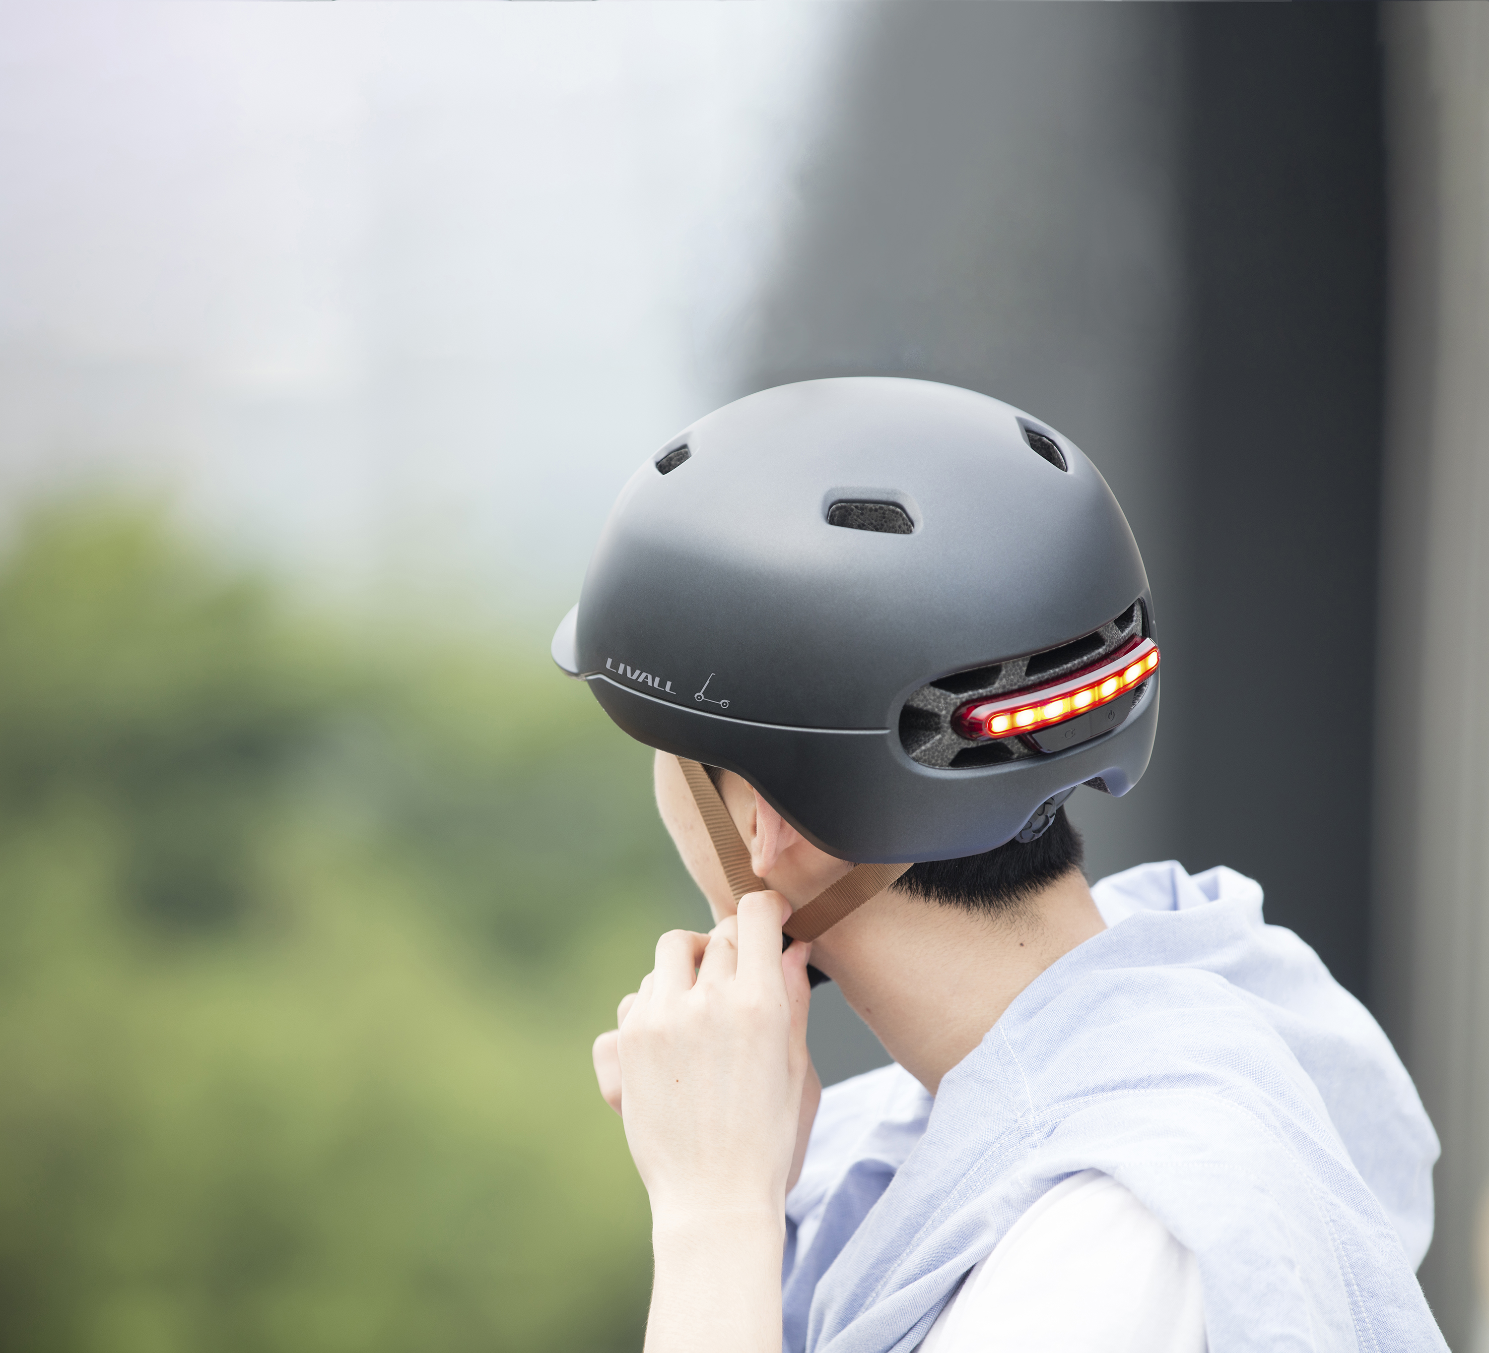
The LIVALL C20 provides more visibility with increased lighting. Great for gifting by helping a loved one to enjoy their commute more with the SMART features, while also helping them be more visible to the surrounding traffic. Not forgetting the peace of mind for everyone at home with the SOS alert.

EVO 21, , MT1 Neo and C20 helmets are available now in Authorized Resellers for 169,00€, 139,00€ and 69,95€ respectively. More information can be found at LIVALL | WaveMotion S.A.

About WaveMotion
WaveMotion, an importer and distributor, is seated in Athens Greece, operating on a wholesale basis, in the consumer electronics, telecommunications and computer industry for over 35 years. WaveMotion S.A. retains the official, exclusive, distribution for the Greek market of important Houses- in leading positions in the Global Sound Arena like JBL, harman/kardon, Cambridge Audio, Kef, Q Acoustics, QED and Goldring.
Newly formed Lifestyle Technology acquired official distribution for rapoo, Livall, Native Union.
Brand Development is the core skill of WaveMotion Team. The vision of our people is to expand WaveMotion’s Brands selection, following our tagline’s principles –Technology, Aesthetics, Design- and continue this journey of Ours, introducing compellingly and establishing decisively these Brands, in the eyes of our customers.

About LIVALL

Founded in 2014 and released the world's first smart & safety cycling helmet in February 2015, LIVALL Tech Co., Ltd. is adept at developing, designing, and manufacturing fashionable and multifunctional patented helmet phones to maximize riders' safety. Committed to becoming the world's best innovative company in the segmented field of smart safety protection equipment, LIVALL has strict standards and massive production capacity to meet the huge market demand. It has obtained more than 170 patents, 30 awards and over 10 international certifications such as CPSC1203, EN1078, CE, FCC, NCC, ROHS, BQB, etc.

